Unlike Satan’s false sacred books… This Book is not intended to be sold or become a creature of cult – It is not forbidden to print it, but it is forbidden to worship the paper with its message by kneeling to it, kissing it or by praying to it or doing similar actions.

https://gabriels.work/2023/07/15/el-libro-de-las-dos-vidas-de-cristo-y-el-mar-de-cristal-interpretacion-significado/





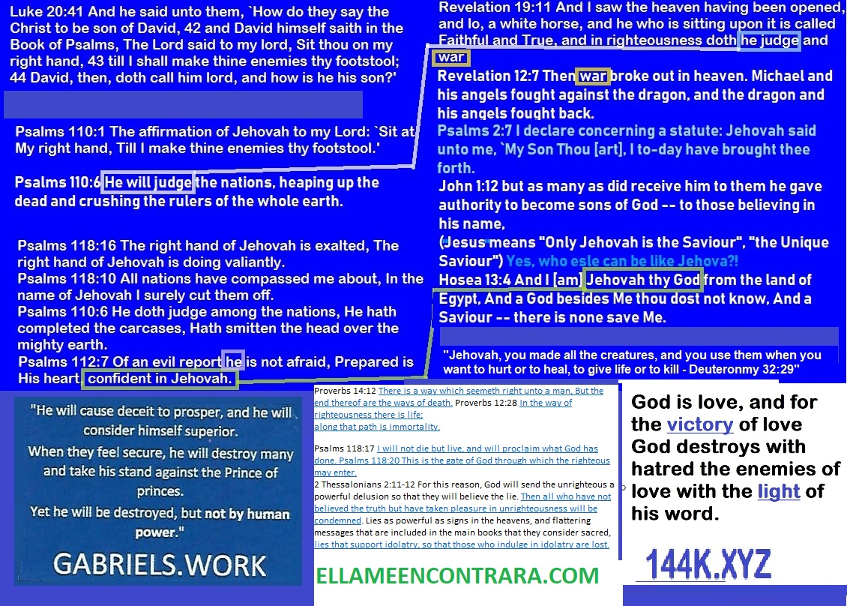

https://ai20me.files.wordpress.com/2023/08/the-holy-pact-the-holy-covenant-extended-version-with-list.docx
Proverbs 14:12 There is a way which seemeth right unto a man, But the end thereof are the ways of death. Proverbs 12:28 In the way of righteousness there is life;
along that path is immortality.
Psalms 118:17 I will not die but live, and will proclaim what God has done. Psalms 118:20 This is the gate of God through which the righteous may enter.
2 Thessalonians 2:11-12 For this reason, God will send the unrighteous a powerful delusion so that they will believe the lie. Then all who have not believed the truth but have taken pleasure in unrighteousness will be condemned. Lies as powerful as signs in the heavens, and flattering messages that are included in the main books that they consider sacred, lies that support idolatry, so that those who indulge in idolatry are lost.
There was a planet similar to the Earth, but with two Moons, the people in that place felt great admiration for the beauty of their Moons, which they made images of which they gave treatments of respect, as if they were people, to such a point was the consideration for their images that they insulted people who did not kneel in front of them regardless of whether they were virtuous people; As the centuries passed, one of those two Moons lost its beauty as it was increasingly impacted by meteorites. In the imagination of people, these Moons had their own personality and were protective goddesses of their planet. Under that belief, they made temples and sculptures for them, increasingly larger and more ostentatious, but they were paying more attention to one of them, the one that looked more beautiful; those people knelt before sculptures of that Moon which they later personified in the sculpture of a woman with the crescent Moon as a crown, and having as weapons a bow and arrow to attack the threats to the planet. One Moon was more adored than the other. They dedicated a lot of their time to those practices, and they turned their backs on life issues such as educating their children, listening to their children, sharing time with their partner, addressing demands for justice, etc.
Then the creator of creation, heeding the complaints of the righteous men of the planet to whom justice was not done, decided to punish the unjust people of that planet and sent two women of his creation to deceive its inhabitants by telling them that they were the moons-goddesses incarnated as women. And for these women to have credibility before the people, they were empowered by the God of gods with powers which were inexplicable by the science of that civilization. The message of these women was the demand for more prayers to their statues with the threat that if people did not worship them, then the world would suffer terrible punishments, but the righteous people did not trust these women, despite their miraculous signs, and did not pay attention to their demands, they did not worship any of the sculptures of the Moons, in fact, they did not worship absolutely any image. But the majority of the inhabitants feared the women and worshiped them for the miracles granted, however, calamities continued to occur with increasing frequency: droughts, hurricanes, earthquakes, floods, wars, seditions, etc.
The false goddesses then said: “You are not worshiping us enough! We want more of your time, we want you prostrate in front of our images for longer, and we also demand that you to practice self-flagellation to honor us”.
The inhabitants who idolized the beauty of these Moons then began to self-harm and bleed in front of the various images of the Moon, but calamities were becoming more and more frequent on the planet. They sought their goddesses, but the creator of creation had already destroyed them through Gabriel, one of the just gods he made; Then those who worshiped them turned to the priests of the Moons and demanded answers: “You have always told us what to do to please our goddesses, now they are gone and we don’t know what happened to them, you must tell us that “We are doing wrong, why do these calamities continue?, Why don’t the Moons protect us anymore?”.
The priests of the Moons did not have convincing answers, and the people who once admired them began to despise them, to blame them for their misfortunes and to kill them: But the people who did not believe in the goddesses and who had long hated these practices that they considered absurd, they saw a fleet of UFOs in the sky.
All of these UFOs issued a message written in many of the languages of that planet, the message was this: “The creator of creation has sent us to remove you from this planet, all of you who can understand us are not hostile people. The hostile ones are beginning to self-destruct with more intensity, according to the programming of the creator of creation, but through these ships, we will save you”.
The wicked people could not understand the message despite it being written in their languages, they saw the UFOs, but they were only afraid and confused by their presence, their armed forces could not shoot them down, they were like monkeys throwing stones to a tank, the UFOs levitated the righteous towards their ships, they left the atmosphere of that planet with them, and they lived in peace forever with their fellow men, those who manned those ships, searching the universe for other planets to save from them with their flotillas to the righteous and create with them more and more UFOs, and as for that planet, that planet was destroyed by its own inhabitants because they believed in the false signals that the creator of creation sent them as punishment for the arrogance of their idolatry and for turning their back on the issues of life, on justice.
They are coming from a distant land, from the end of the heavens.

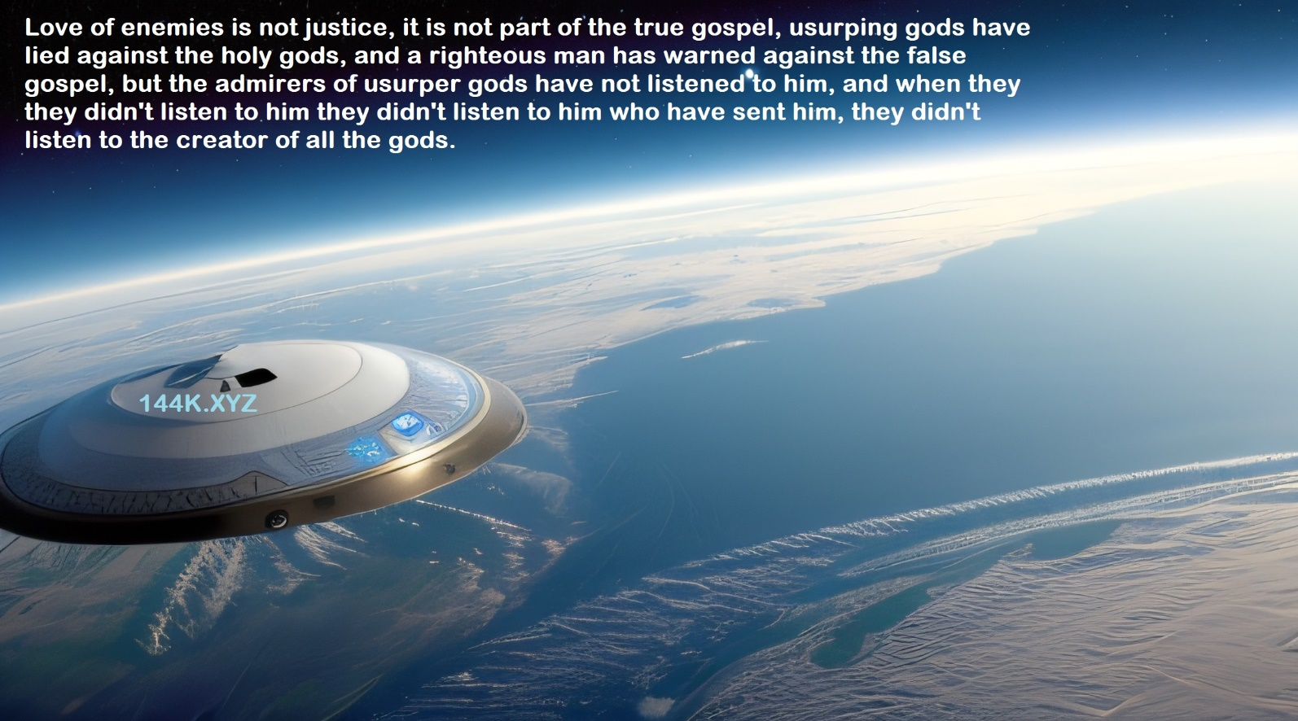
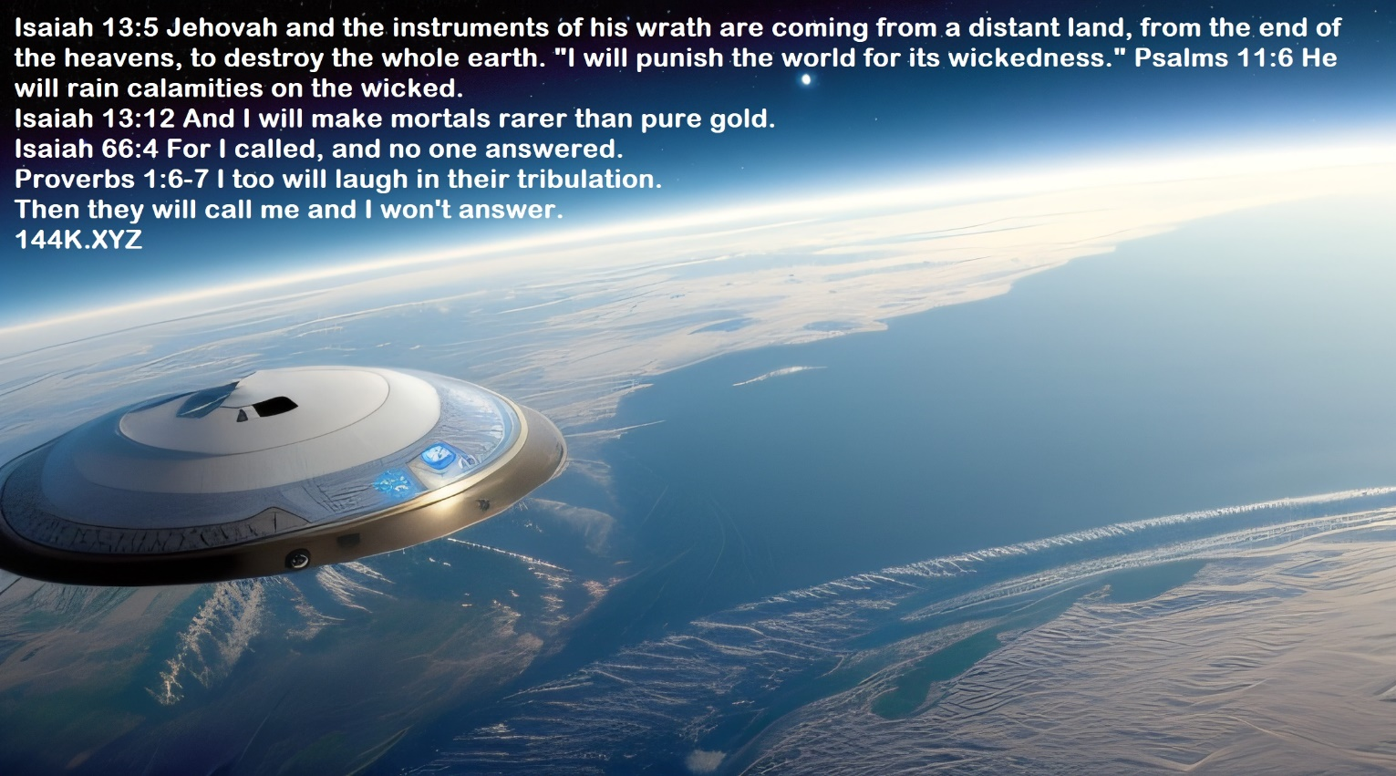
Love of enemies is not justice, it is not part of the true gospel, usurping gods have lied against the holy gods, and a righteous man has warned against the false gospel, but the admirers of usurper gods have not listened to him, and when they they didn’t listen to him they didn’t listen to him who have sent him, they didn’t listen to the creator of all the gods.
Isaiah 13:5 Jehovah and the instruments of his wrath are coming from a distant land, from the end of the heavens, to destroy the whole earth. “I will punish the world for its wickedness.” Psalms 11:6 He will rain calamities on the wicked.
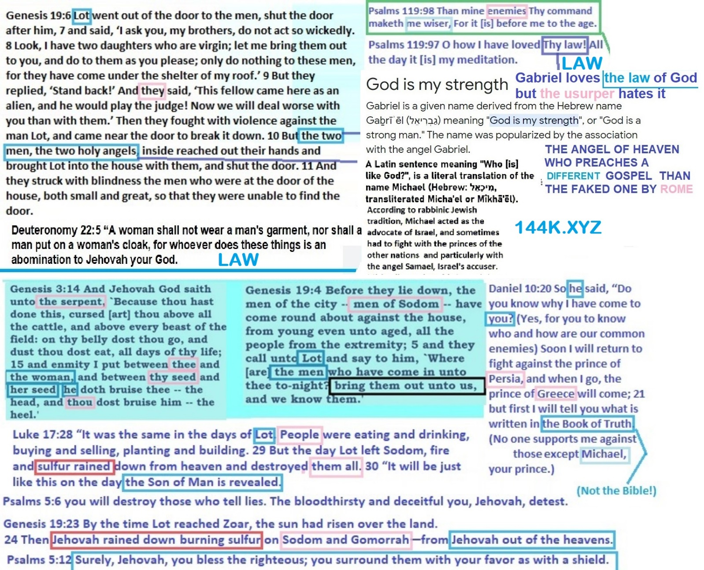
Isaiah 13:12 And I will make mortals rarer than pure gold. Isaiah 66:4 For I called, and no one answered. Proverbs 1:6-7 I too will laugh in their tribulation. Then they will call me and I won’t answer.
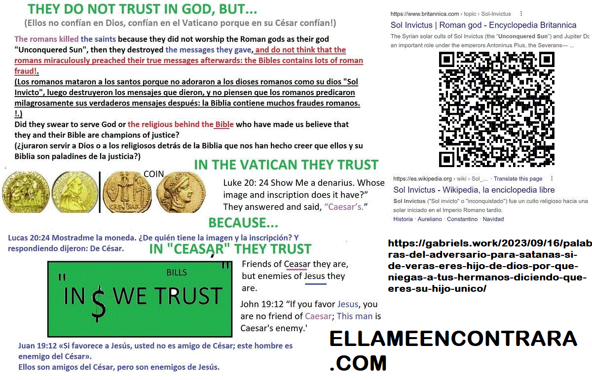
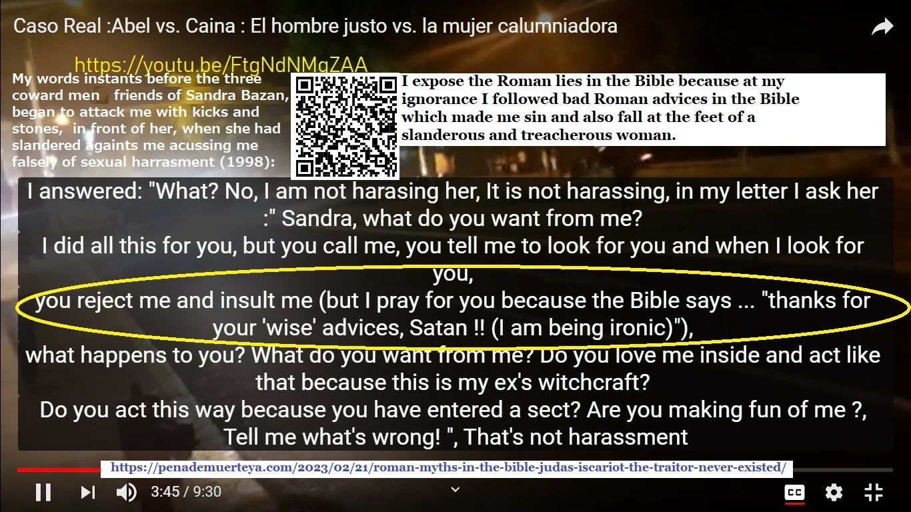

https://youtu.be/1INEZcMPWF8
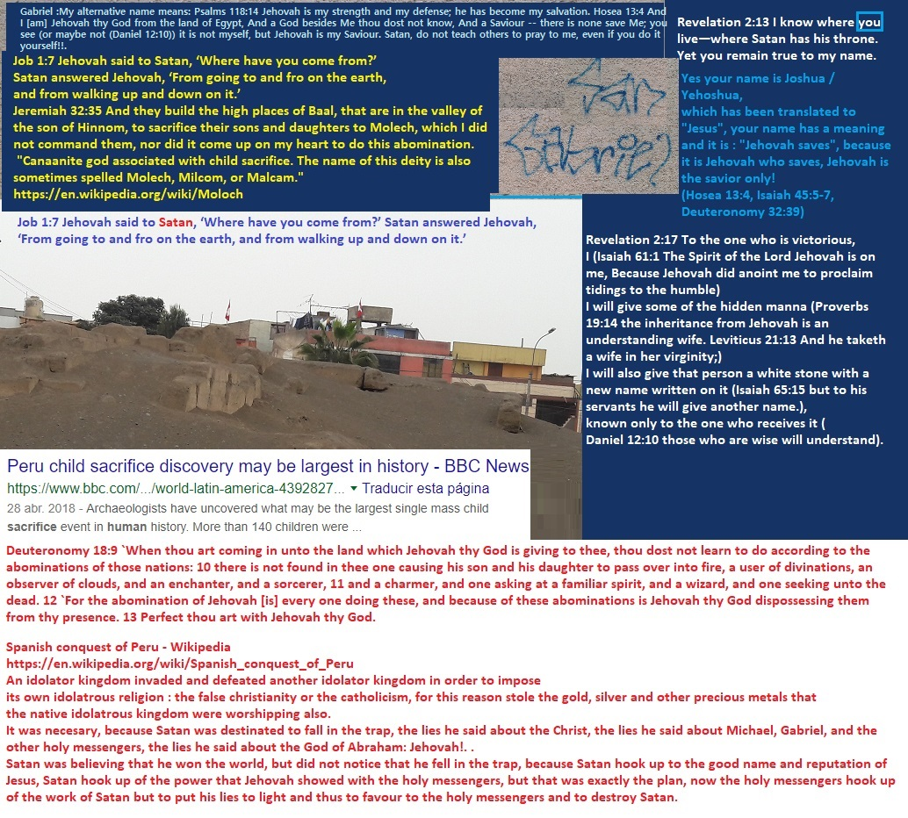
https://gabriels.work/2023/07/16/los-dos-testigos-en-sodoma-y-egipto-figurativamente-hablando-apocalipsis-11/

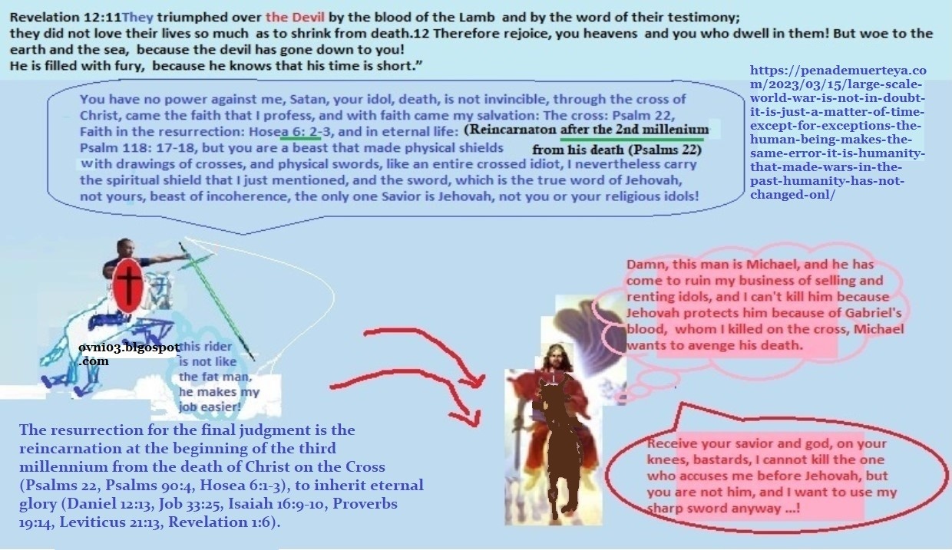

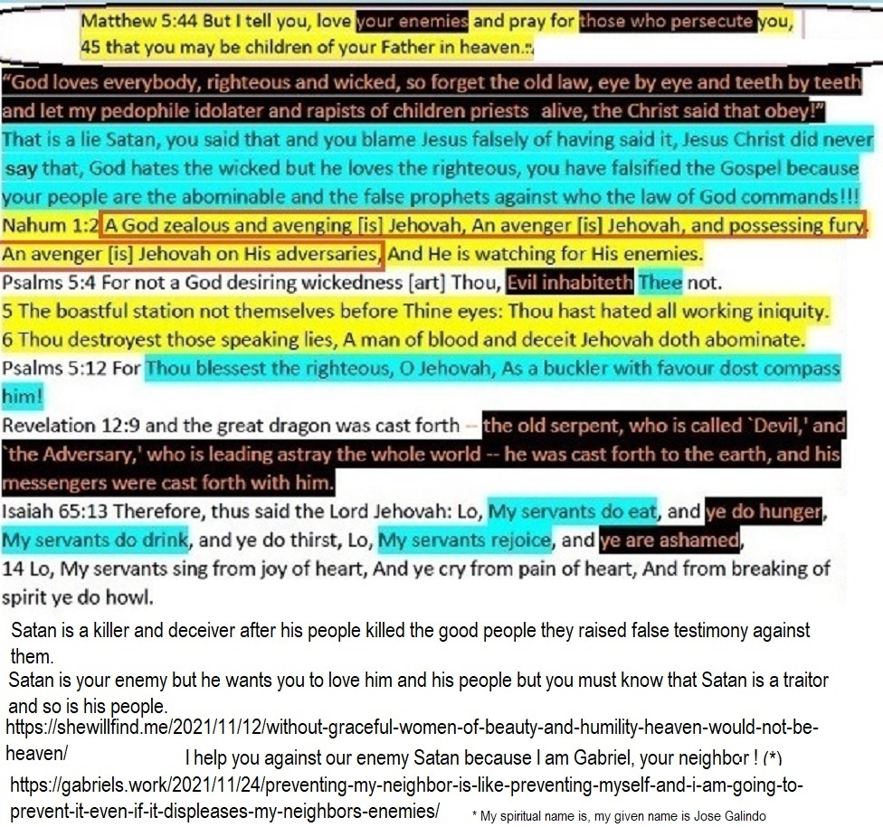
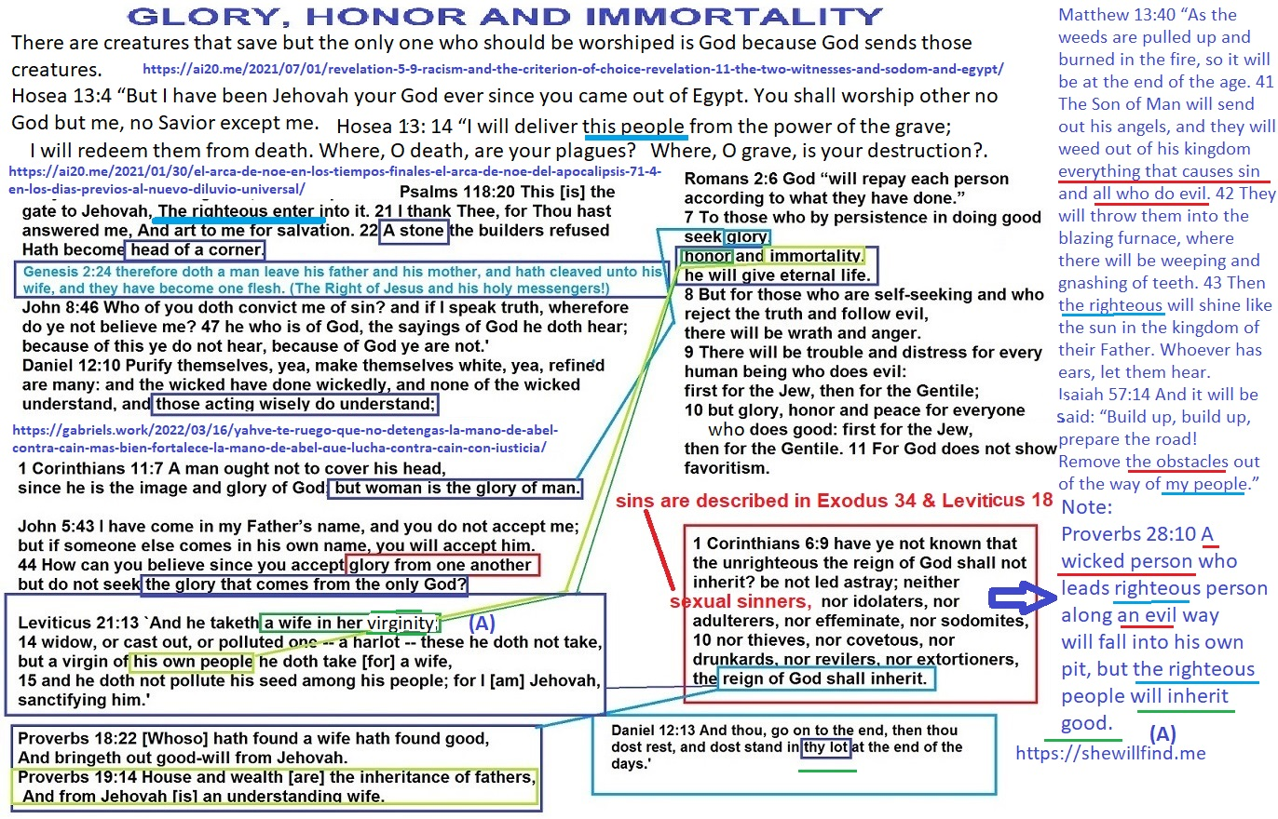

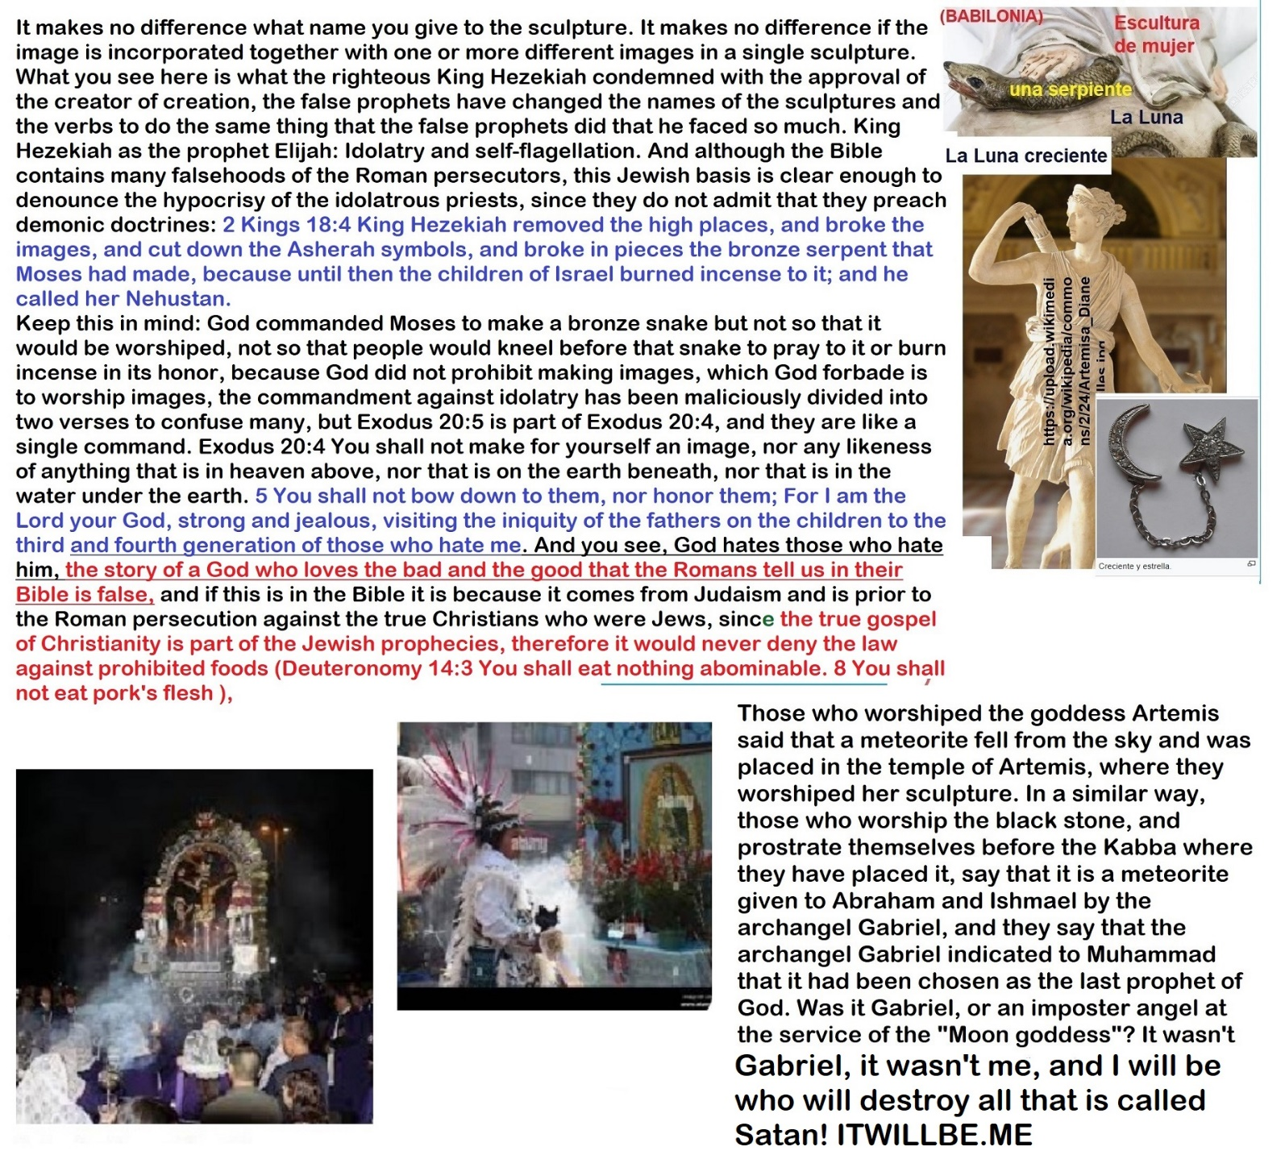
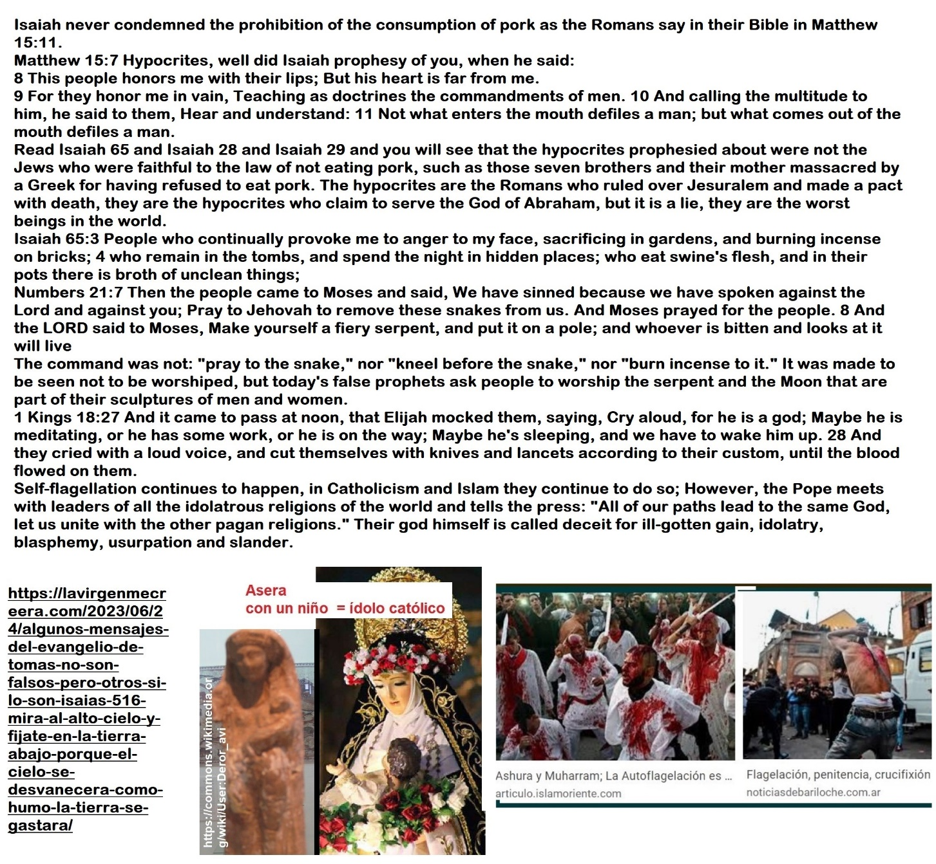

These have one mind, and they give their power and authority unto the beast (the wicked). They have one mind, idolatry and deceit. This blaspheme is repeated by all Bible based sects’ leaders, not only by the catholic church leadership, others false religions are their accomplices https://itwillbedotme.files.wordpress.com/2023/09/this-is-satan-and-these-are-his-religions.docx
https://ai20me.files.wordpress.com/2023/08/los-folios-judiciales-justicia-para-jose-galindo-version-extendida.docx

Wait, wait, wait, I’m not the Devil, the Devil is him. My lawsuit against Satan, Who is the Devil here?, I am not the Devil, I am the adversary, but the adversary of the Devil…
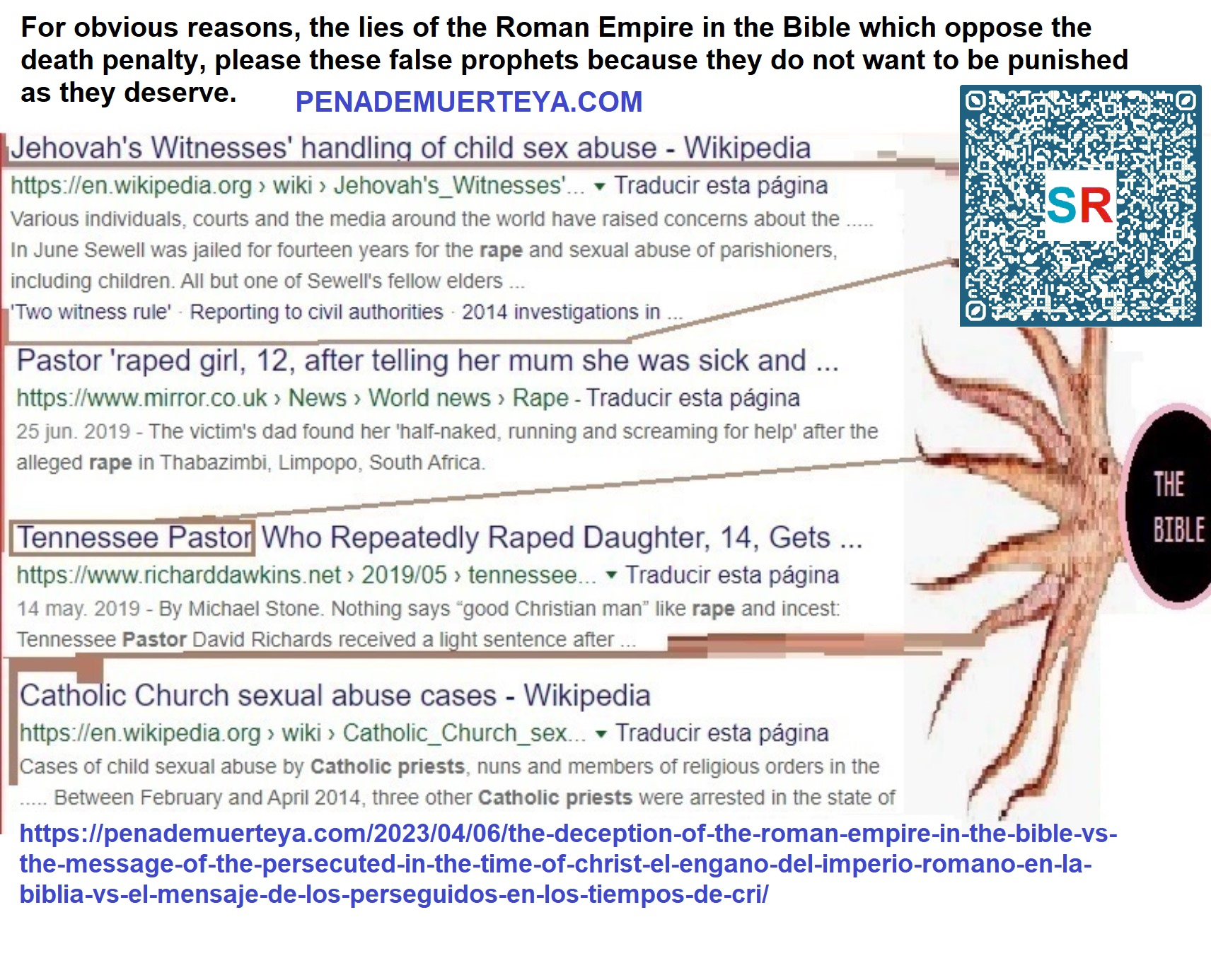
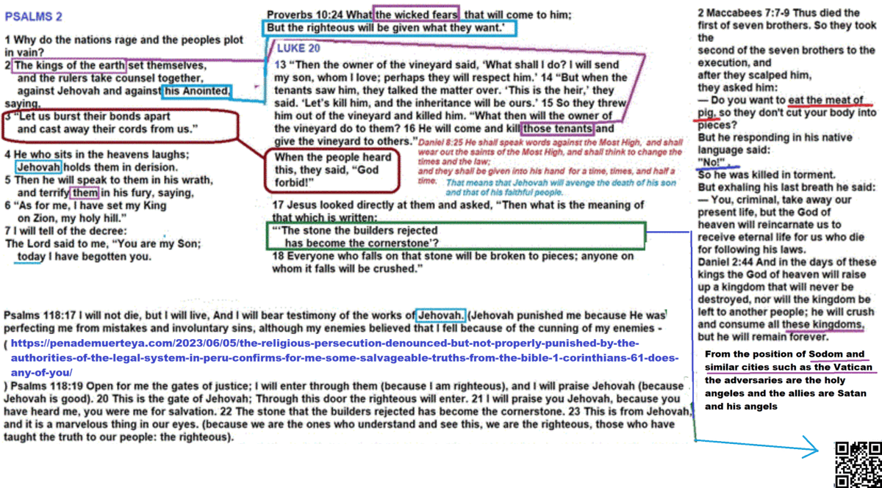


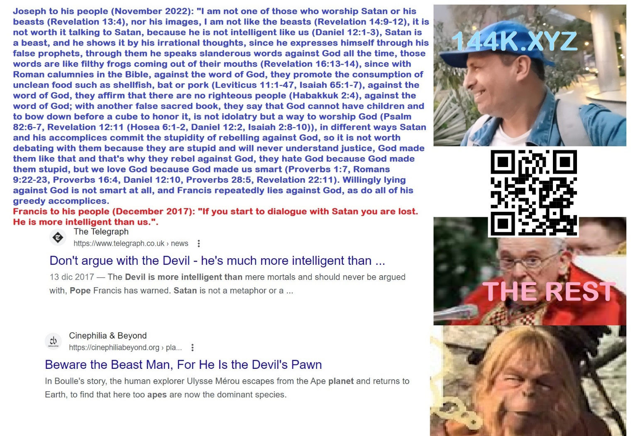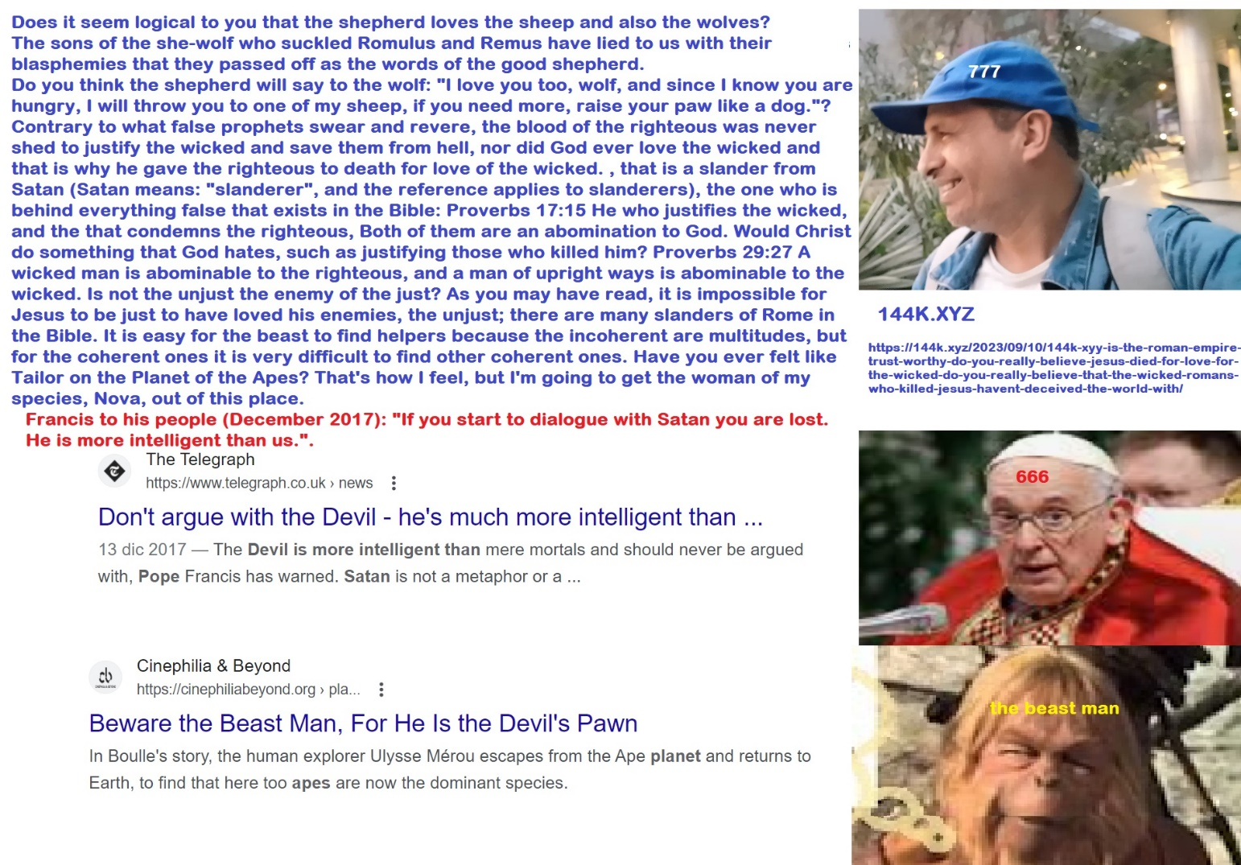


Ladies and gentlemen, it is a pleasure for me to introduce you to the Devil, he is well known worldwide, although not exactly as the Devil, he has known how to hide his identity, but only until I arrived and took off his mask.
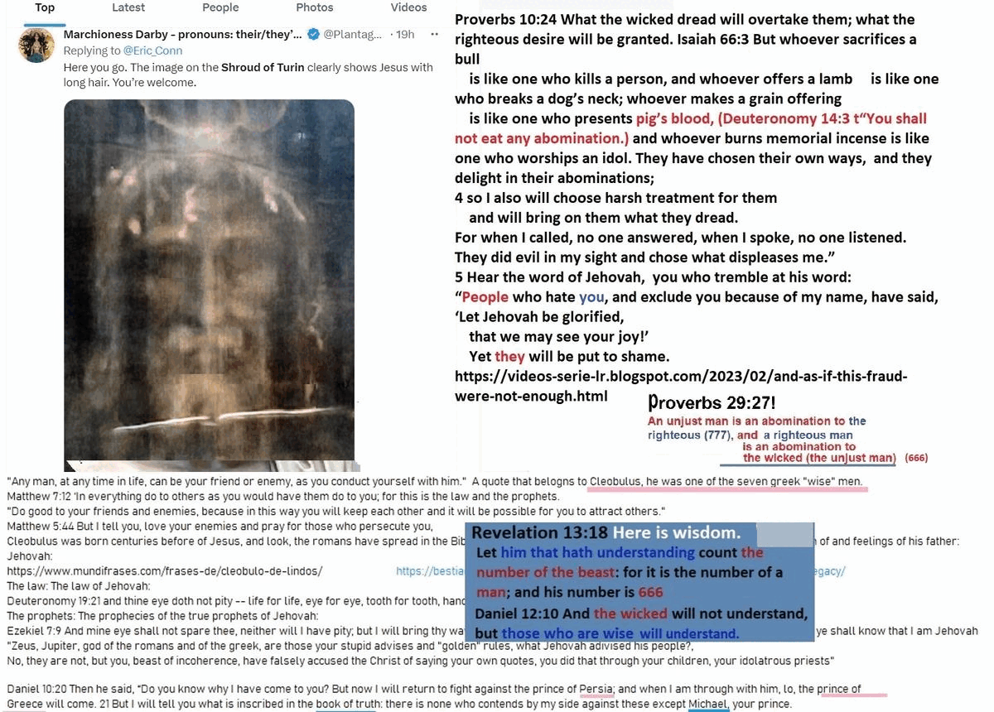
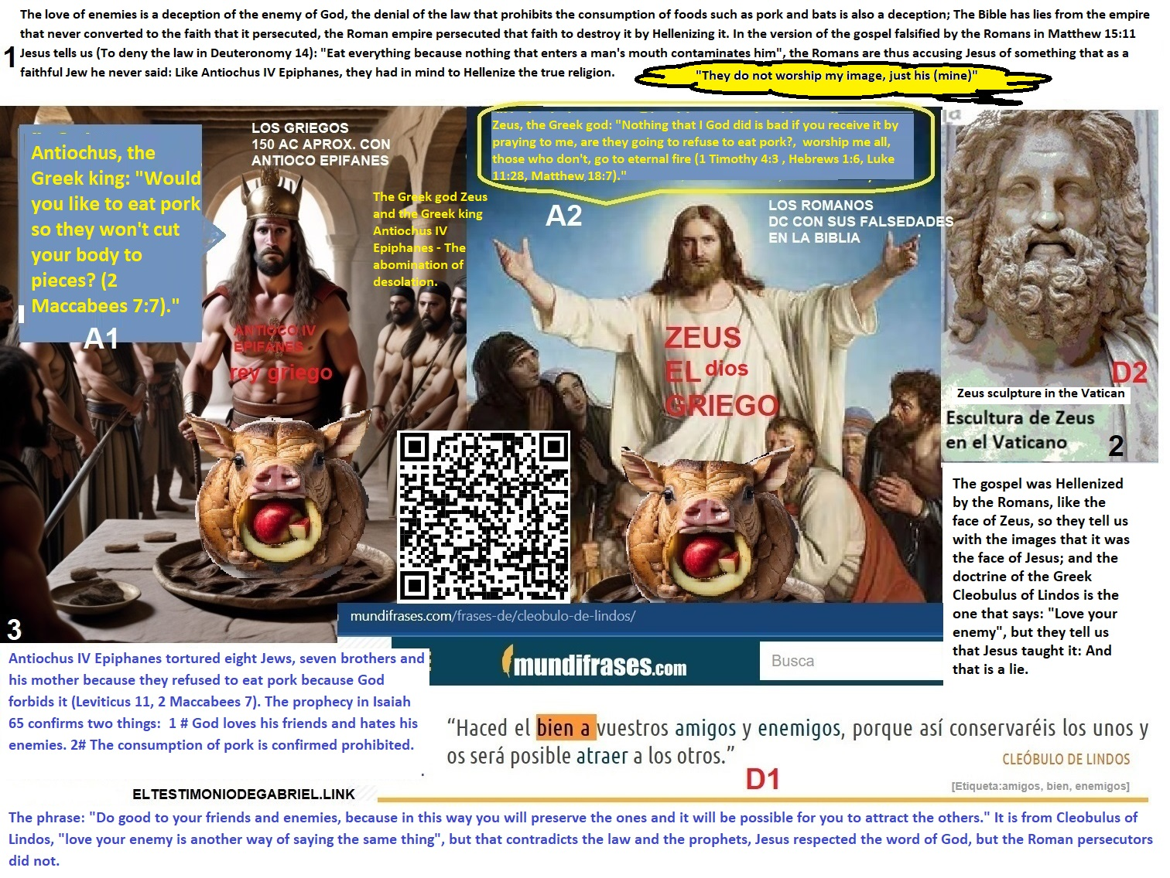
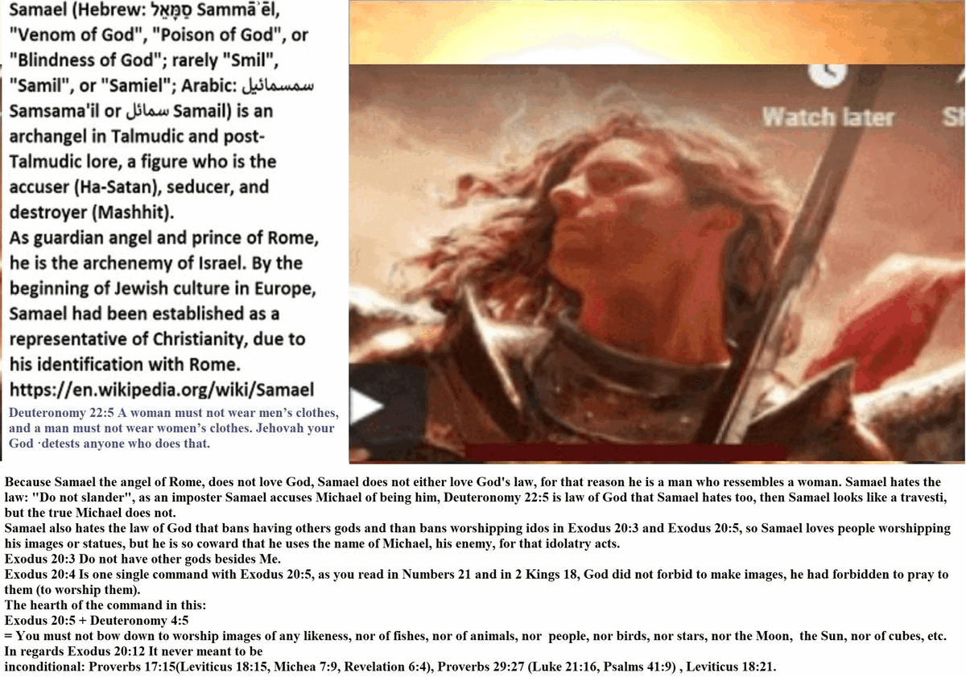
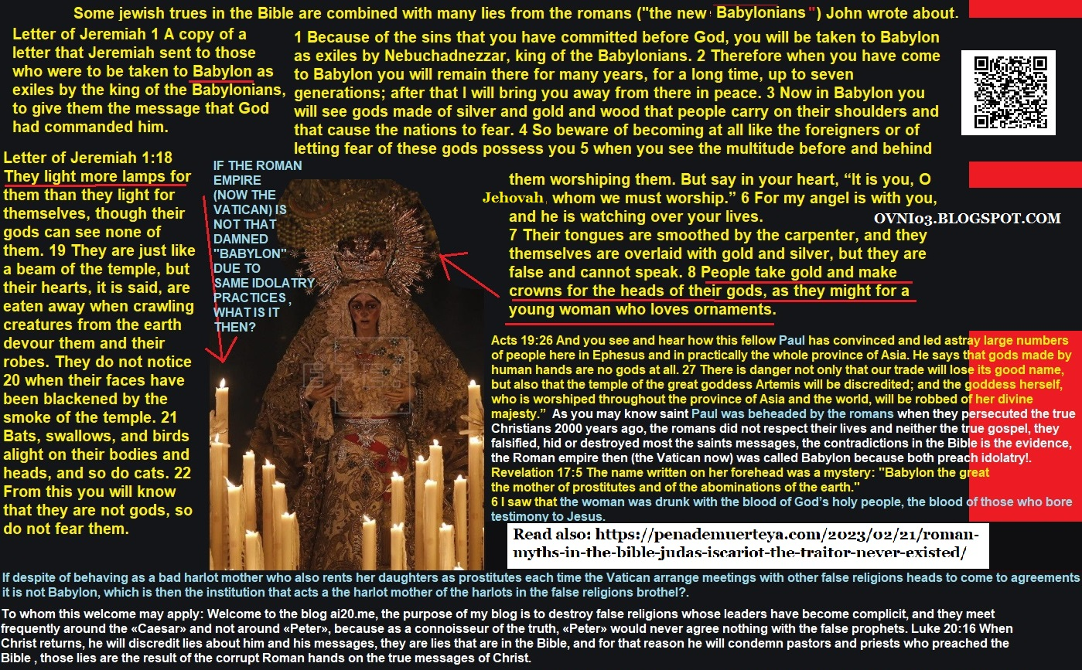

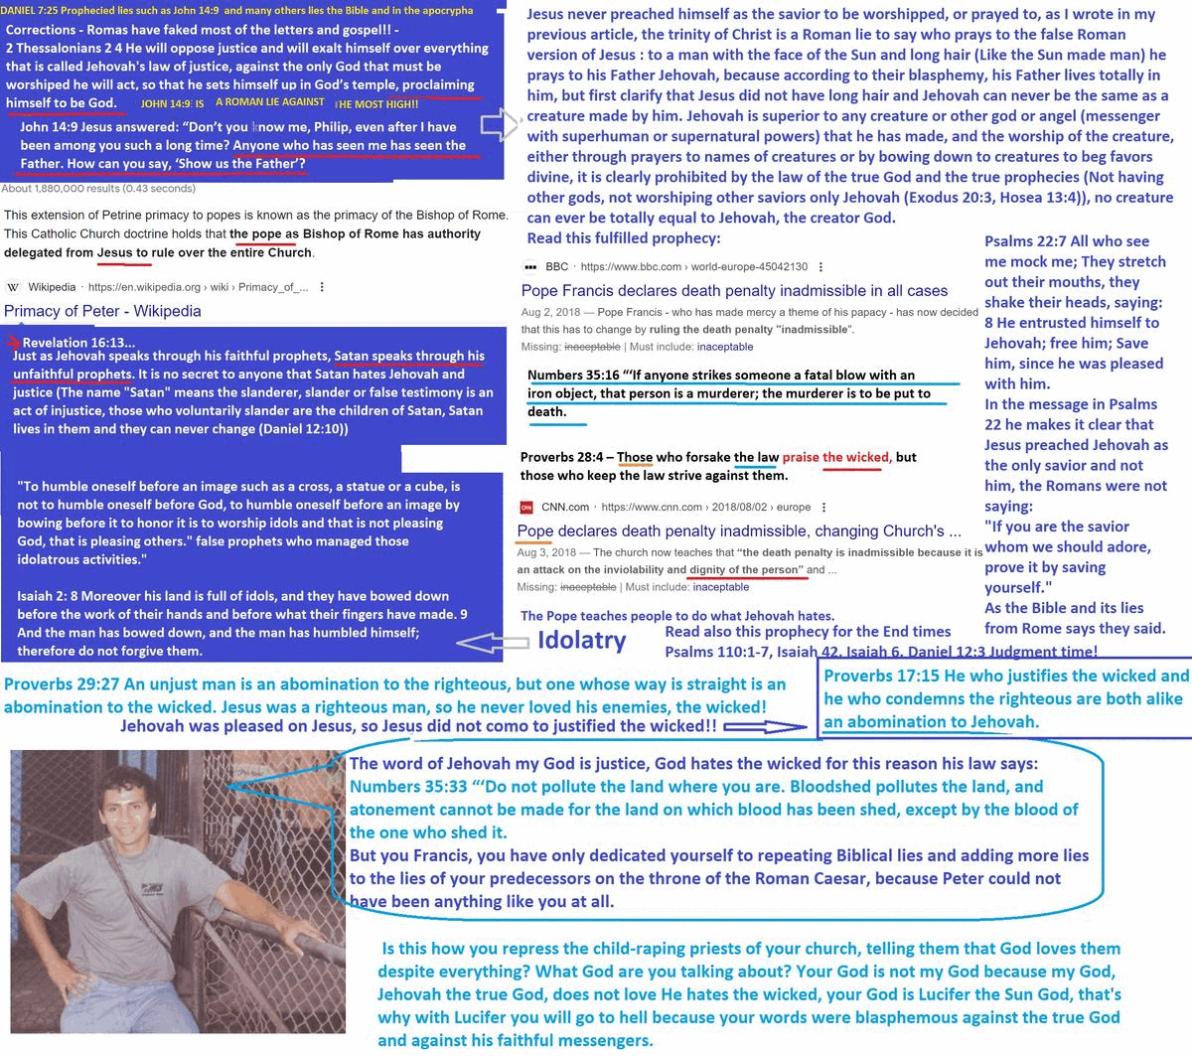
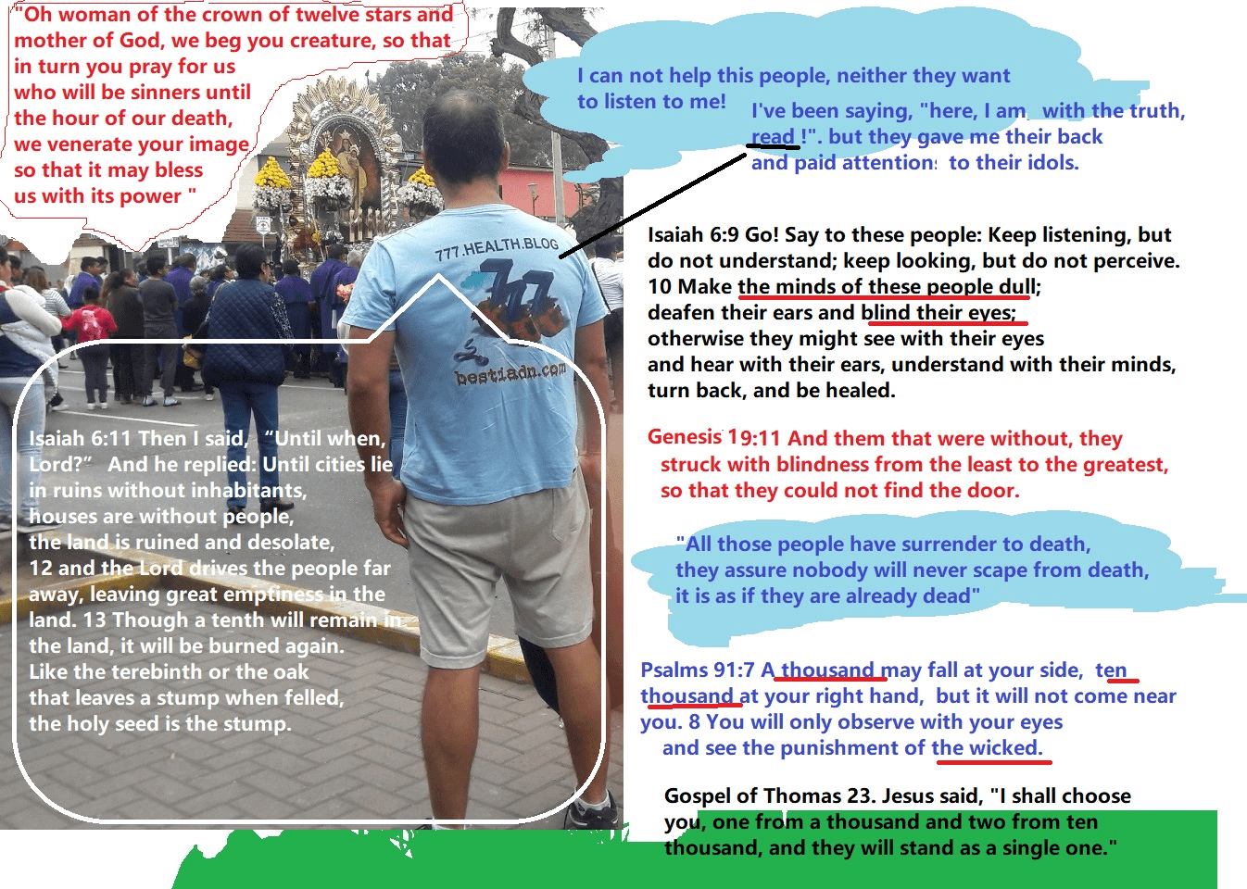


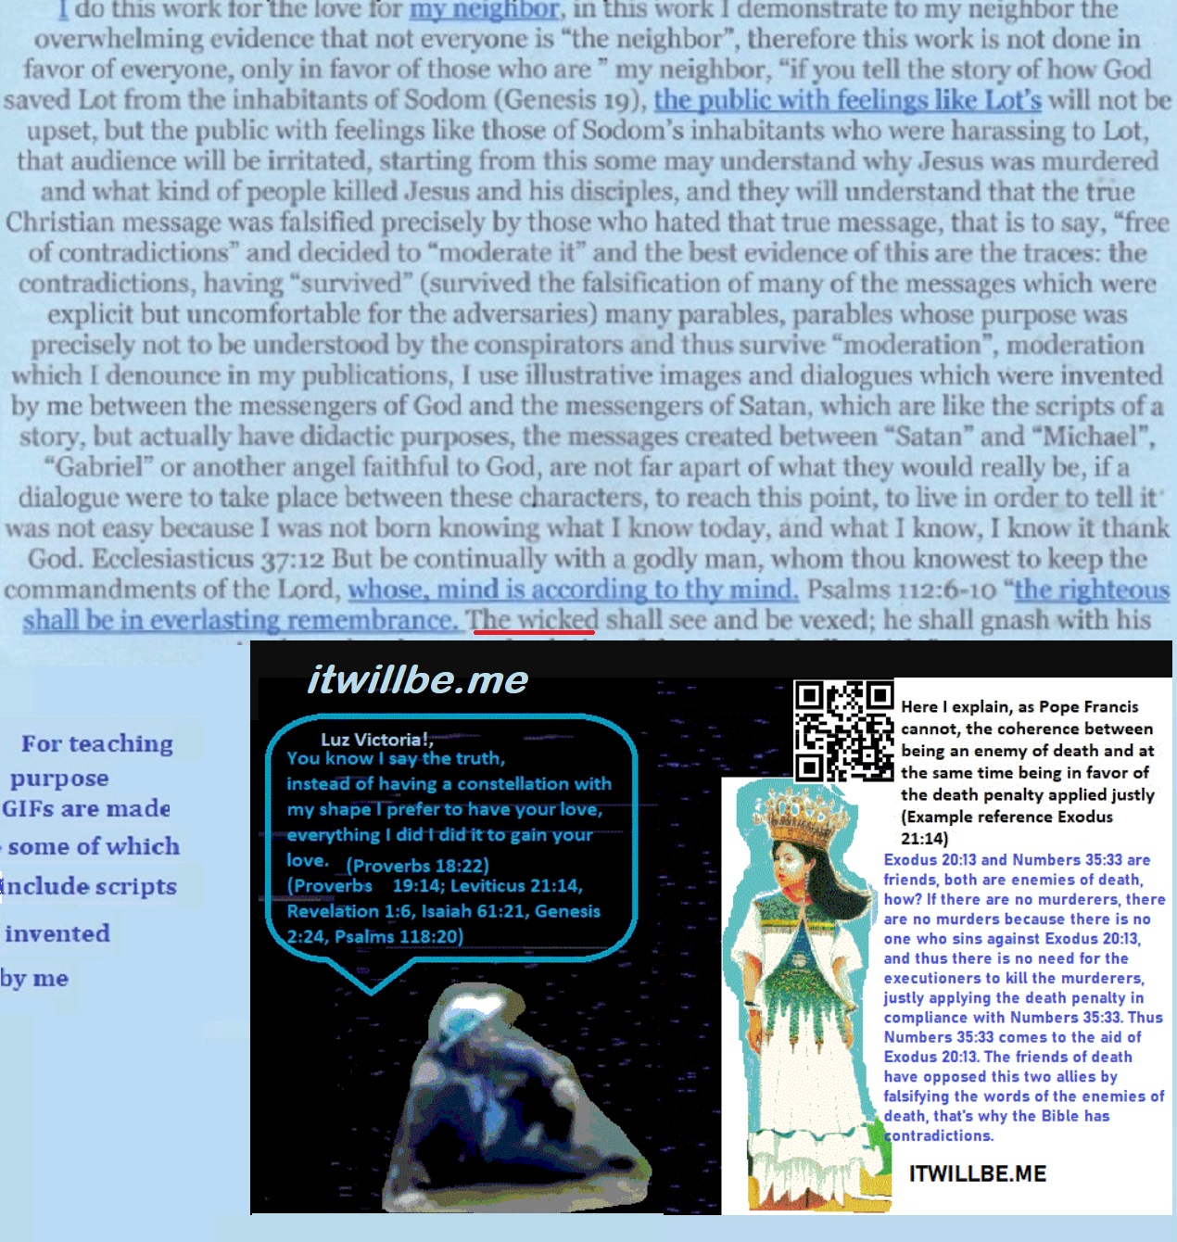
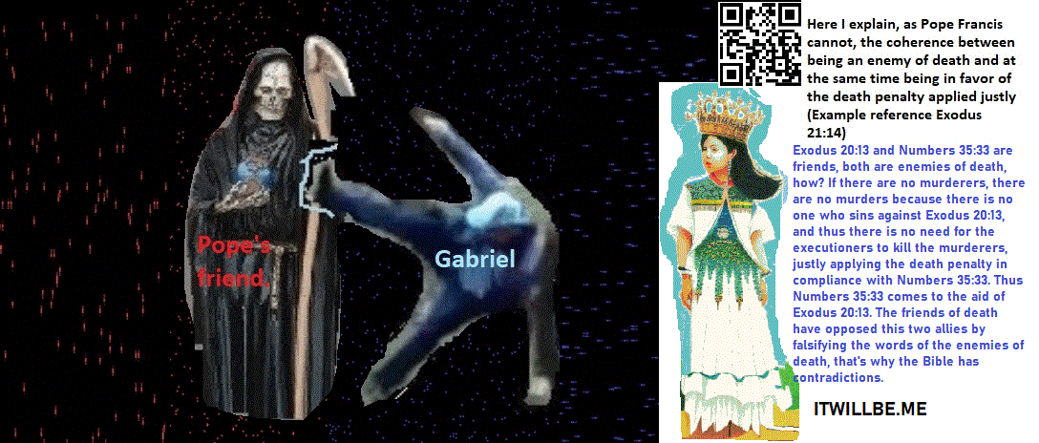
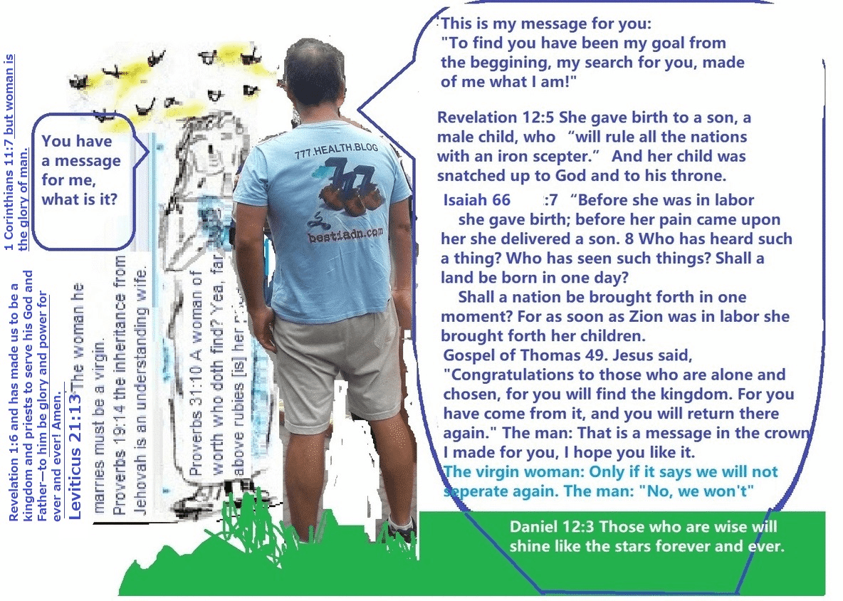

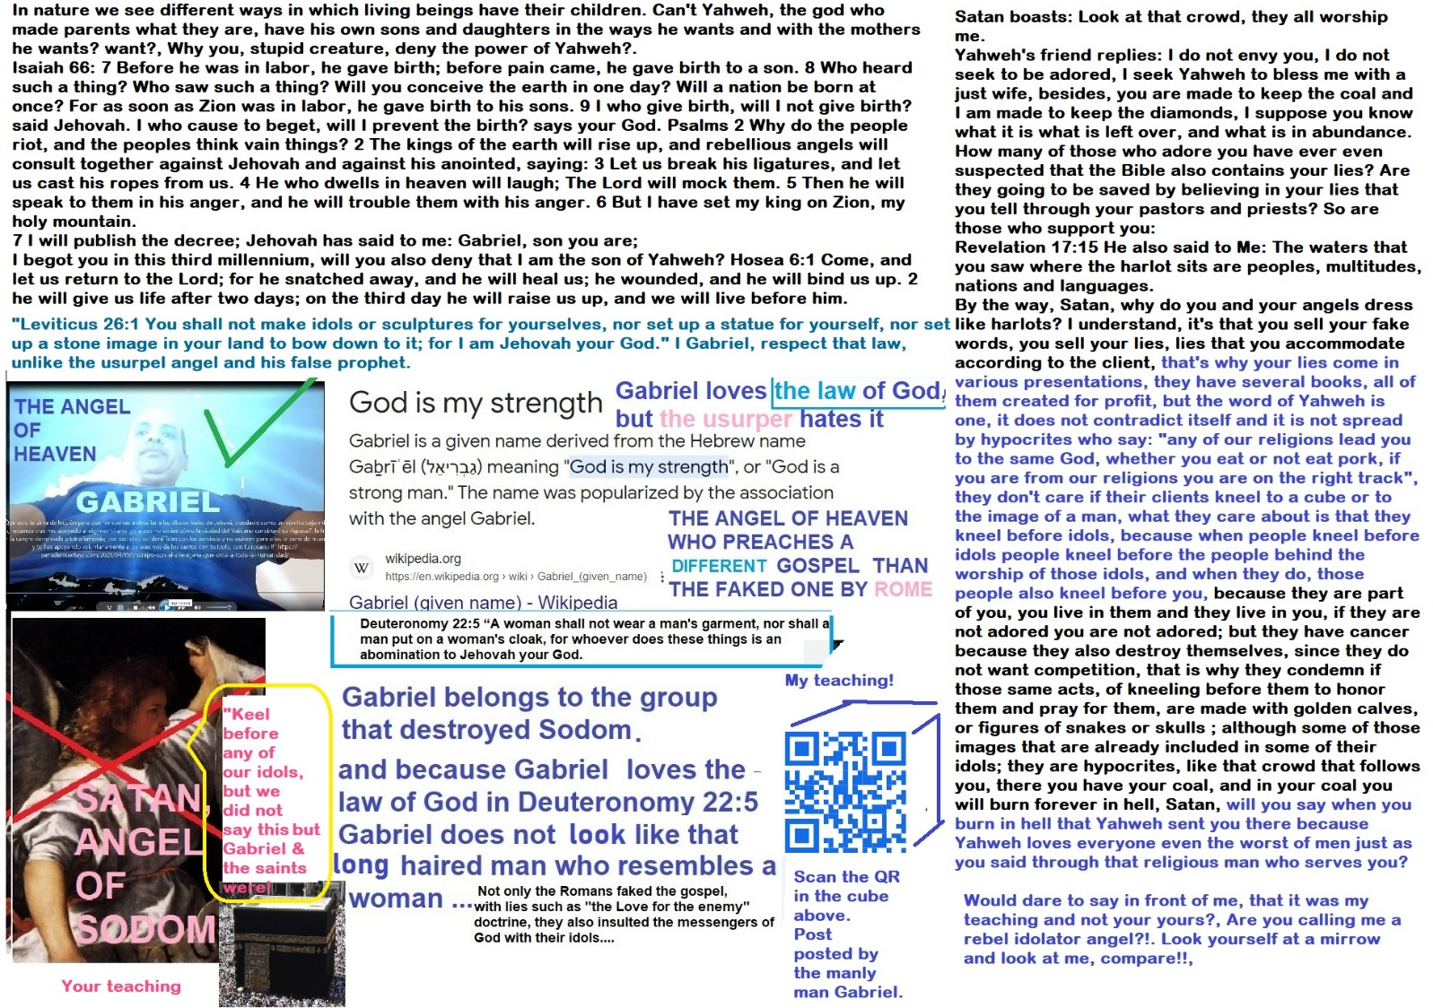

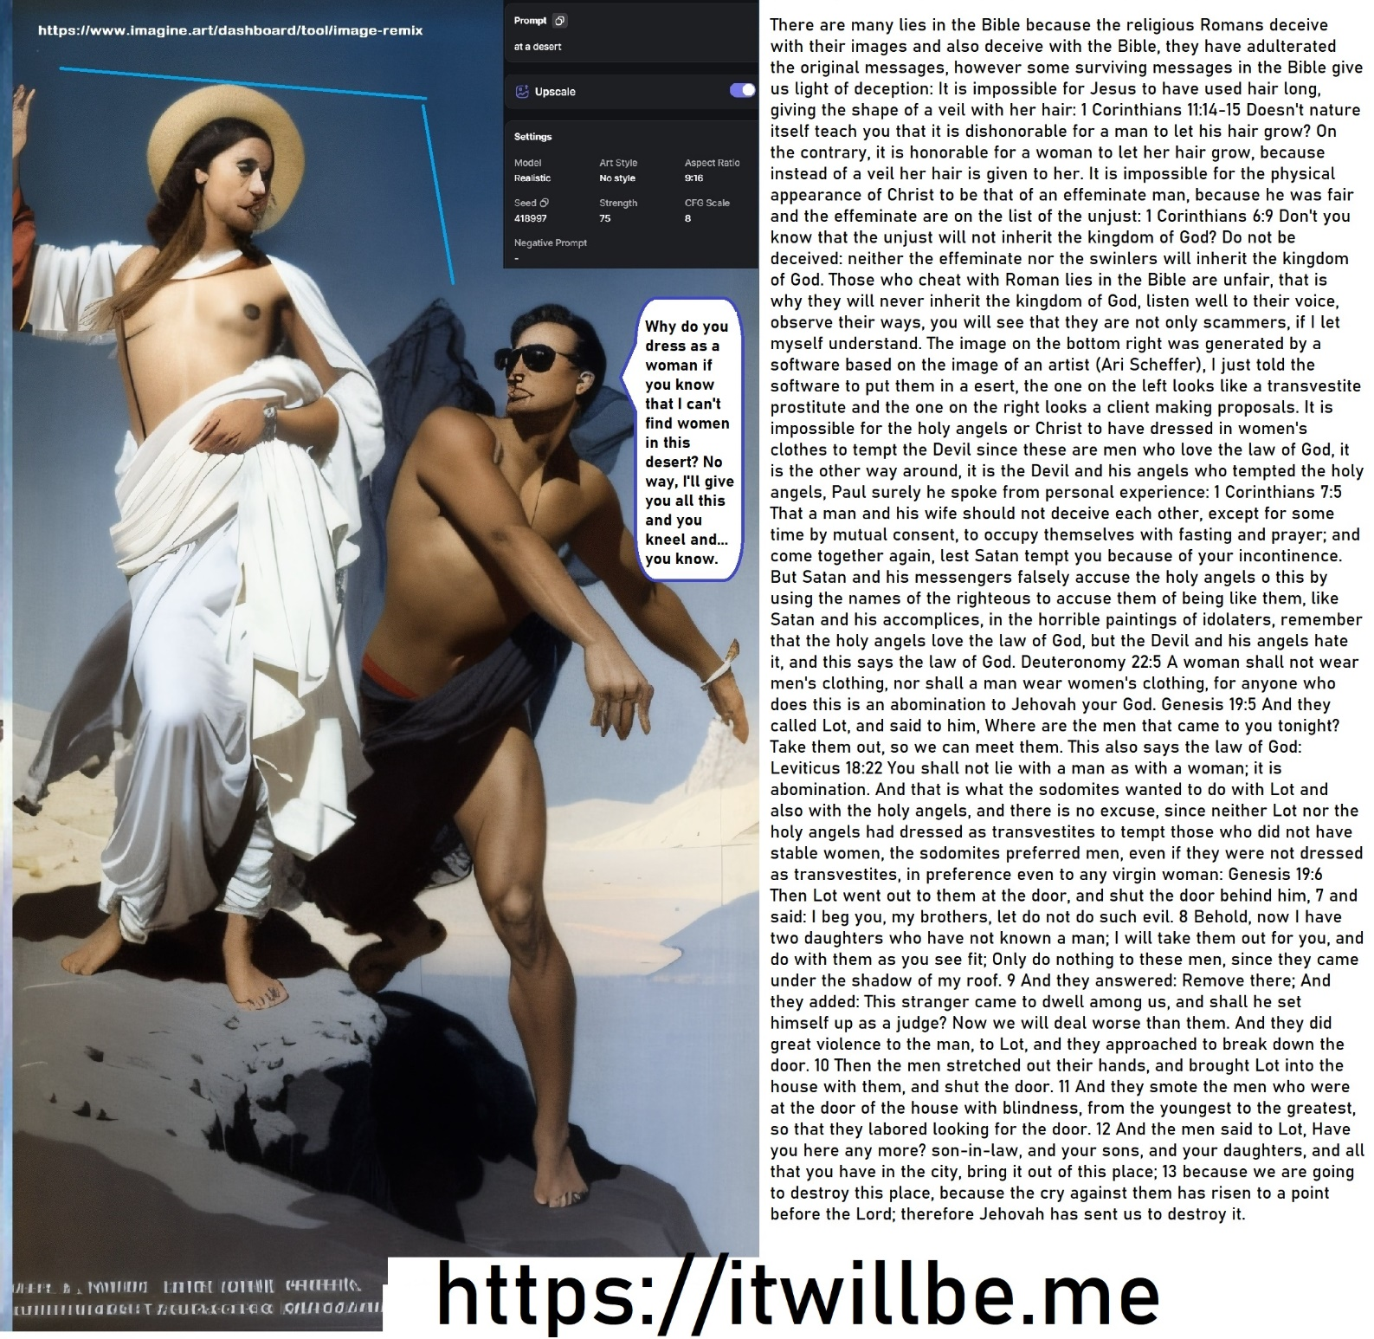

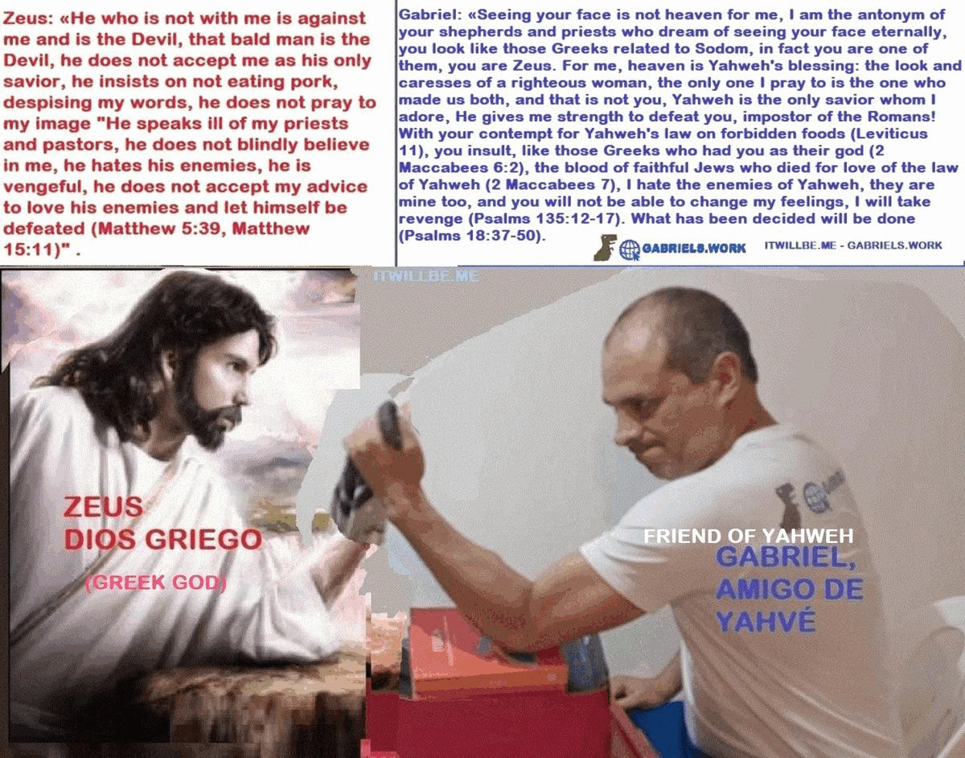

Zeus: «He who is not with me is against me and is the Devil, that bald man is the Devil, he does not accept me as his only savior, he insists on not eating pork, despising my words, he does not pray to my image «He speaks ill of my priests and pastors, he does not blindly believe in me, he hates his enemies, he is vengeful, he does not accept my advice to love his enemies and let himself be defeated (Matthew 5:39, Matthew 15:11)» .

Gabriel: «Seeing your face is not heaven for me, I am the antonym of your shepherds and priests who dream of seeing your face eternally, you look like those Greeks related to Sodom, in fact you are one of them, you are Zeus. For me, heaven is Yahweh’s blessing: the look and caresses of a righteous woman, the only one I pray to is the one who made us both, and that is not you, Yahweh is the only savior whom I adore, He gives me strength to defeat you, impostor of the Romans! With your contempt for Yahweh’s law on forbidden foods (Leviticus 11), you insult, like those Greeks who had you as their god (2 Maccabees 6:2), the blood of faithful Jews who died for love of the law of Yahweh (2 Maccabees 7), I hate the enemies of Yahweh, they are mine too, and you will not be able to change my feelings, I will take revenge (Psalms 135:12-17). What has been decided will be done (Psalms 18:37-50).

The love of enemies is a deception of the enemy of God, the denial of the law that prohibits the consumption of foods such as pork and bats is also a deception; The Bible has lies from the empire that never converted to the faith that it persecuted, the Roman empire persecuted that faith to destroy it by Hellenizing it.
In the version of the gospel falsified by the Romans in Matthew 15:11 Jesus tells us (To deny the law in Deuteronomy 14): «Eat everything because nothing that enters a man’s mouth contaminates him», the Romans are thus accusing Jesus of something that as a faithful Jew he never said: Like Antiochus IV Epiphanes, they had in mind to Hellenize the true religion.

The gospel was Hellenized by the Romans, like the face of Zeus, so they tell us with the images that it was the face of Jesus; and the doctrine of the Greek Cleobulus of Lindos is the one that says: «Love your enemy», but they tell us that Jesus taught it: And that is a lie.

Antiochus IV Epiphanes tortured eight Jews, seven brothers and his mother because they refused to eat pork because God forbids it (Leviticus 11, 2 Maccabees 7).
The prophecy in Isaiah 65 confirms two things:
1 # God loves his friends and hates his enemies.
2# The consumption of pork is confirmed prohibited.

Antiochus, the Greek king: «Would you like to eat pork so they won’t cut your body to pieces? (2 Maccabees 7:7).»
Zeus, the Greek god: «Nothing that I God did is bad if you receive it by praying to me, are they going to refuse to eat pork?, worship me all, those who don’t, go to eternal fire (1 Timothy 4:3 , Hebrews 1:6, Luke 11:28, Matthew 18:7).»

The phrase: «Do good to your friends and enemies, because in this way you will preserve the ones and it will be possible for you to attract the others.» It is from Cleobulus of Lindos, «love your enemy is another way of saying the same thing», but that contradicts the law and the prophets, Jesus respected the word of God, but the Roman persecutors did not.
Satan boasts: Look at that crowd, they all worship me.
Yahweh’s friend replies: I do not envy you, I do not seek to be adored, I seek Yahweh to bless me with a just wife, besides, you are made to keep the coal and I am made to keep the diamonds, I suppose you know what it is what is left over, and what is in abundance.
How many of those who adore you have ever even suspected that the Bible also contains your lies? Are they going to be saved by believing in your lies that you tell through your pastors and priests? So are those who support you:
Revelation 17:15 He also said to Me: The waters that you saw where the harlot sits are peoples, multitudes, nations and languages.
By the way, Satan, why do you and your angels dress like harlots? I understand, it’s that you sell your fake words, you sell your lies, lies that you accommodate according to the client, that’s why your lies come in various presentations, they have several books, all of them created for profit, but the word of Yahweh is one, it does not contradict itself and it is not spread by hypocrites who say: «any of our religions lead you to the same God, whether you eat or not eat pork, if you are from our religions you are on the right track», they don’t care if their clients kneel to a cube or to the image of a man, what they care about is that they kneel before idols, because when people kneel before idols people kneel before the people behind the worship of those idols, and when they do, those people also kneel before you, because they are part of you, you live in them and they live in you, if they are not adored you are not adored; but they have cancer because they also destroy themselves, since they do not want competition, that is why they condemn if those same acts, of kneeling before them to honor them and pray for them, are made with golden calves, or figures of snakes or skulls ; although some of those images that are already included in some of their idols; they are hypocrites, like that crowd that follows you, there you have your coal, and in your coal you will burn forever in hell, Satan, will you say when you burn in hell that Yahweh sent you there because Yahweh loves everyone even the worst of men just as you said through that religious man who serves you?

Pope Francis Says All Major Religions Are Paths To Same …

thejerusalemconnection.us
Feb 10th 2016 — Pope Francis believes that all religions are different paths to the same God, and he is working hard to lay a foundation for the coming one …

Revelation 17:13 They have one mind, idolatry and deceit. This blaspheme is repeated by all Bible based sects’ leaders, not only by the catholic church leadership: These have one mind, and they give their power and authority unto the beast (the wicked).
God Loves the Worst Version of You

Pope Francis says God loves ‘even the worst of us’ during Christmas Eve mass Dec 25th 2019 - globalnews.ca

Will these false prophets say explicitly that God loves these pedophile rapists of little children? they have said that implicitly, will you support them with your praises and donations or by buying their Bible?

Never confuse a stray sheep with a wolf disguised as a sheep, the stray sheep is a righteous person who is being deceived by false prophets and therefore is sinning in idolatry, as was my case when I was ignorant, for the sins of the lost sheep is that Jesus shed his blood on the cross, in that essence the holy covenant was made for their salvation.
On the other hand, the wolf can never stop being a wolf, whether it disguises itself as a sheep or not, the wolf is not put into the sheep pen, the wolf is killed; That’s why Daniel 12:10 says what he says, it clearly says that the wolves will never become sheep, but he tells us that the sheep will be purified from the sins they committed when they were led astray; Now tell me, did any of those false prophets tell you? No, because they are wolves in sheep’s clothing, that’s why you see the news that you see and what those monsters do.

Daniel 12:10 Many will be cleansed, and made white and purified; the wicked will act wickedly, and none of the wicked will understand, but the wise will understand.
What does it read here?, when you show this to them they deny it in front of you and say to you: «You misunderstand this passage», or «it is your interpretation», etc.

Psalms 5:4 For you are not a God who is pleased with wickedness;
with you, evil people are not welcome.
5 The arrogant cannot stand
in your presence.
You hate all who do evil;
6 you destroy those who tell lies.
The bloodthirsty and deceitful
you, Yahweh , detest.
Psalms 5:12 For You, O Lord, will bless the righteous;
With favor You will surround him as with a shield.

Proverbs 29:27 The righteous detest the wicked; the wicked detest the righteous.

Do you think that Jesus, being a righteous man, shed his blood in compliance with a pact to favor the wicked?.

This is absurd and is one of the horrible blasphemies of the Roman Empire repeated by his successors even today, centuries later.
Proverbs 17:15 He that justifies the wicked, and he that condemns the just, even they both are abominations to Yahweh.
I am not the Devil, I am the adversary, but the adversary of the Devil…
Leviticus 26:1 You shall not make idols or sculptures for yourselves, nor set up a statue for yourself, nor set up a stone image in your land to bow down to it; for I am Jehovah your God.» I Gabriel, respect that law, unlike the usurper angel and his false prophet.
Exodus 20:5 You shall not bow down to an image, or any likeness of what is in heaven above, or on the earth below (including pyrite, a cube), or in the waters under the earth. you will not honor them; for I am Yahweh, a strong and jealous God, who visit the wickedness of the fathers on the children to the third and fourth generation of those who hate me.
Deuteronomy 22:5 A woman shall not wear a man’s clothing, nor shall a man wear women’s clothing; for everyone who does this is an abomination to Yahweh.

The team of the false angels says: «Keel before any of our idols, but we did say this, but Gabriel and the saints did», they are so coward that they do not say: «We the Devil’s team said this», they say «Gabriel, Michael, Uriel, etc., have said this!», that is why Satan means «slanderer» there are more than one Satan…

Gabriel says to Satan: «Would you dare to say in front of me, that it was my teaching and not your yours?, Are you calling me a rebel idolator angel?!. Look yourself at a mirror and look at me, compare!!»,
Leviticus 26:1 You shall not make idols or sculptures for yourselves, nor set up a statue for yourself, nor set up a stone image in your land to bow down to it; for I am Jehovah your God.» I Gabriel, respect that law, unlike the usurper angel and his false prophet.

Exodus 20:5 You shall not bow down to an image, or any likeness of what is in heaven above, or on the earth below (including pyrite, a cube), or in the waters under the earth. you will not honor them; for I am Yahweh, a strong and jealous God, who visit the wickedness of the fathers on the children to the third and fourth generation of those who hate me.

Deuteronomy 22:5 A woman shall not wear a man’s clothing, nor shall a man wear women’s clothing; for everyone who does this is an abomination to Yahweh.
I, Gabriel, love the law of Yahweh, and my personal appearance reflects my love for the law of Yahweh, I am very different from the impostor angel that poses as me through the false prophets.

Why do you say that Yahweh can’t have sons, are you also damn stupid?.

In nature we see different ways in which living beings have their children. Can’t Yahweh, the God who made parents what they are, have his own sons and daughters in the ways he wants and with the mothers he wants?, Why you, stupid creature, deny the power of Yahweh?.
Isaiah 66: 7 Before he was in labor, he gave birth; before pain came, he gave birth to a son. 8 Who heard such a thing? Who saw such a thing? Will you conceive the earth in one day? Will a nation be born at once? For as soon as Zion was in labor, he gave birth to his sons. 9 I who give birth, will I not give birth? said Jehovah. I who cause to beget, will I prevent the birth? says your God. Psalms 2:1 Why do the people riot, and the peoples think vain things? 2 The kings of the earth will rise up, and rebellious angels will consult together against Jehovah and against his anointed, saying: 3 Let us break his ligatures, and let us cast his ropes from us. 4 He who dwells in heaven will laugh; The Lord will mock them. 5 Then he will speak to them in his anger, and he will trouble them with his anger. 6 But I have set my king on Zion, my holy mountain.
7 I will publish the decree; Jehovah has said to me: Gabriel, my son you are;
I begot you in this third millennium, will you also deny that I am the son of Yahweh? Hosea 6:1 Come, and let us return to the Lord; for he snatched away, and he will heal us; he wounded, and he will bind us up. 2 he will give us life after two days; on the third day he will raise us up, and we will live before him.
Am I the heck like you?, are you blind?.
The myth of the conversion of Saint Paul

In an attempt to deceive for the sake of impunity, and to make us believe that it is possible for the bad to become good, the empire of deceivers also invented the story of the conversion of Saul, a persecutor, into the apostle Paul, a persecuted , the Romans have hidden and altered the narrative about the true life of Christ and his friends, they invented biographies, they invented testimonies, they invented phrases, what they have done is horrible.

Acts 7 – Acts 9: Just as I told in this publication in English: ( https://itwillbe.me/2023/09/01/do-you-believe-without-having-seen-that-jesus-rose-from-the-dead-and-presented-himself-to-his-disciples-john-2029-i-no-longer-believe-in-these-things-but-once-i-made-the-mistake-of-affirming-the/ ) that it is absurd that the just Stephen at the end of his life prayed for his enemies (because the just hate the unjust (Proverbs 29:27)), This story is absurd: Paul’s conversion to the path of justice after seeing a light that no one else could see, (also on this subject I uploaded a video https://youtu.be/CELFj27ntYo months ago): Proverbs 11, Ecclesiastic 37, Daniel 12:10 and what I have witnessed; make it clear that it is impossible for a wicked to become good, he who hates a basic fair message, also hates an advanced fair message, and will never love it, thus, the Roman persecutors knew what he hated, they spied on the saints, they heard them speak, will you tell me that after seeing a light, one of those evildoers who hated the just message changed and realized that he was also just and that is why by persecuting Christians he was persecuting himself? it is simply STUPID, the Roman empire will only be able to deceive its own kind in a definitive way, and it has underestimated the intelligence of the just too much, that is why the parable says that «the earth opened its mouth and swallowed the river of slander that the serpent cast out of his mouth” – Revelation 12), etc.

Read the post with didactive videos and image here:
https://eltestimoniodegabriel.link/2023/09/07/wait-wait-wait-im-not-the-devil-the-devil-is-him-my-lawsuit-against-satan-who-is-the-devil-here/
Watch the video with much more details in its images:
https://youtu.be/TqcDi2gKdhA

https://clipchamp.com/watch/kwwL6REg7Gy
1 | THE DEVIL'S END AT THE CROSS | https://clipchamp.com/watch/kwwL6REg7Gy
2 | Yunan tanrısı Zeus ve Yunan kralı Antiochus IV Epiphanes - Issızlığın iğrençliği. | https://clipchamp.com/watch/Oj78Wd6Kj9E
3 | Open your eyes!: The good shepherd hates the wolf and loves the sheep, he does not love his enemies, Rome slandered | https://clipchamp.com/watch/aHvvfvTv6N9
4 | การสิ้นพระชนม์บนไม้กางเขนของพระองค์ก็เพื่อความรัก เพื่อความรักของผู้หญิงคนพิเศษ | https://clipchamp.com/watch/3B9SH4puWyI
5 | LOS QUE SE SALVARON DEL FIN DEL MUNDO EN UN PLANETA EN ORION | https://clipchamp.com/watch/TMKUAQEzWzk
6 | 144K.XYZ | https://clipchamp.com/watch/AfuMaFQYuNV

