I am destroying the lies of the founders of Christianity and Islam against Gabriel, the angel of Judaism who announces a message very different from that announced by the corrupt Romans.
Because I am Gabriel!
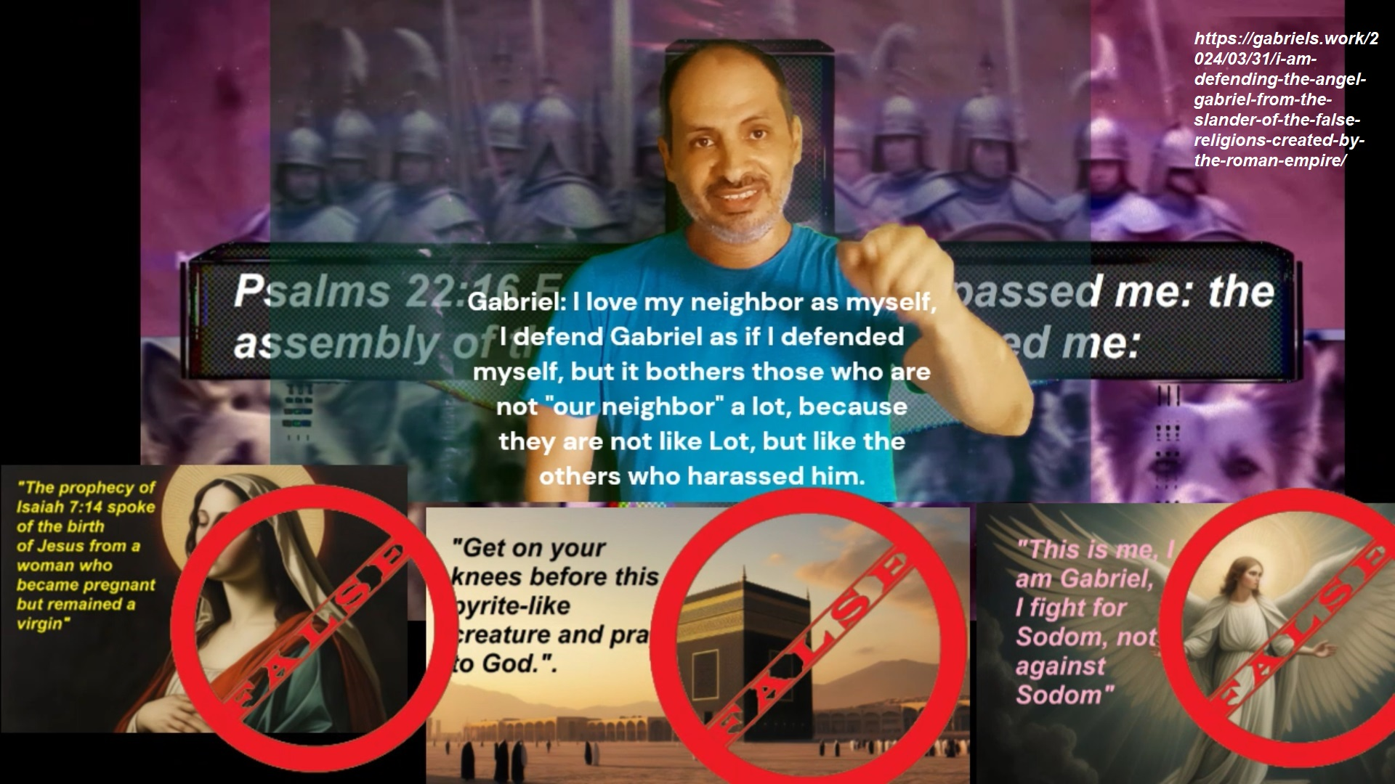
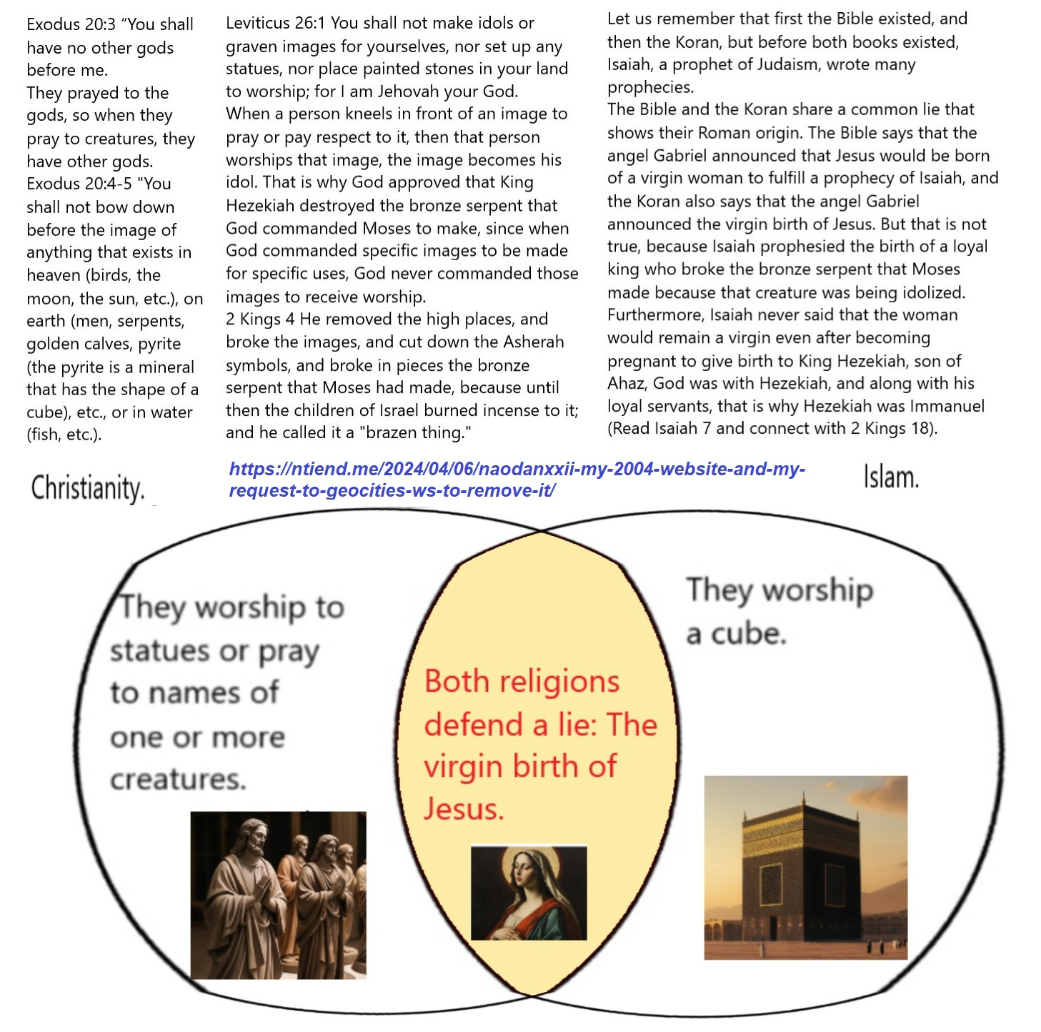

A call to flee false religions (Including Christianity, because the Bible has also Roman falsehoods!):
An "UFO" calls from heaven, or a "trumpet" calls from heaven:


“‘Come out of the harlot [and out her harlot daughters], my people,’
so that you will not share in their sins,
so that you will not receive any of their plagues;
for their sins are piled up to heaven, and God has remembered their crimes.»
Then at that time, Michael, the great prince who stands over your people, will arise. There will be a time of distress that has not happened from the first time that there was a nation until that time. At that time your people will be delivered, everyone who is found written in the book.
Revelation 18:4-5 plus Daniel 12:1-2 message.
Exodus 20:3 “You shall have no other gods before me.
They prayed to the gods, so when they pray to creatures, they have other gods.
Exodus 20:4-5 «You shall not bow down before the image of anything that exists in heaven (birds, the moon, the sun, etc.), on earth (men, serpents, golden calves, pyrite (the pyrite is a mineral that has the shape of a cube), etc., or in water (fish, etc.).
Leviticus 26:1 You shall not make idols or graven images for yourselves, nor set up any statues, nor place painted stones in your land to worship; for I am Jehovah your God.
When a person kneels in front of an image to pray or pay respect to it, then that person worships that image, the image becomes his idol. That is why God approved that King Hezekiah destroyed the bronze serpent that God commanded Moses to make, since when God commanded specific images to be made for specific uses, God never commanded those images to receive worship.
Let us remember that first the Bible existed, and then the Koran, but before both books existed, Isaiah, a prophet of Judaism, wrote many prophecies.
The Bible and the Koran share a common lie that shows their Roman origin. The Bible says that the angel Gabriel announced that Jesus would be born of a virgin woman to fulfill a prophecy of Isaiah, and the Koran also says that the angel Gabriel announced the virgin birth of Jesus. But that is not true, because Isaiah prophesied the birth of a loyal king who broke the bronze serpent that Moses made because that creature was being idolized. Furthermore, Isaiah never said that the woman would remain a virgin even after becoming pregnant to give birth to King Hezekiah, son of Ahaz, God was with Hezekiah, and along with his loyal servants, that is why Hezekiah was Immanuel (Read Isaiah 7 and connect with 2 Kings 18).
Christianity: They worship statues or pray to names of one or more creatures.
Islam: They worship a cube.

They have slandered Gabriel and they have lied to us!

I love my neighbor as myself, I defend Gabriel as if I defended myself, but it bothers those who are not “our neighbor” a lot, because they are not like Lot, but like the others who harassed him.https://youtu.be/gj5OisbVvx0
Defending Gabriel from Satan’s slander.

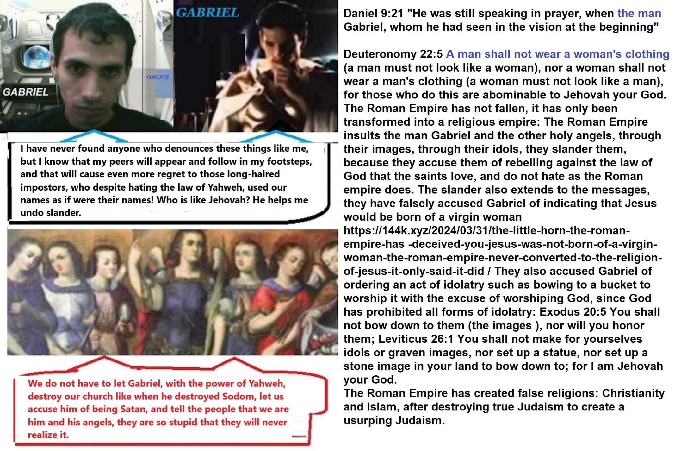
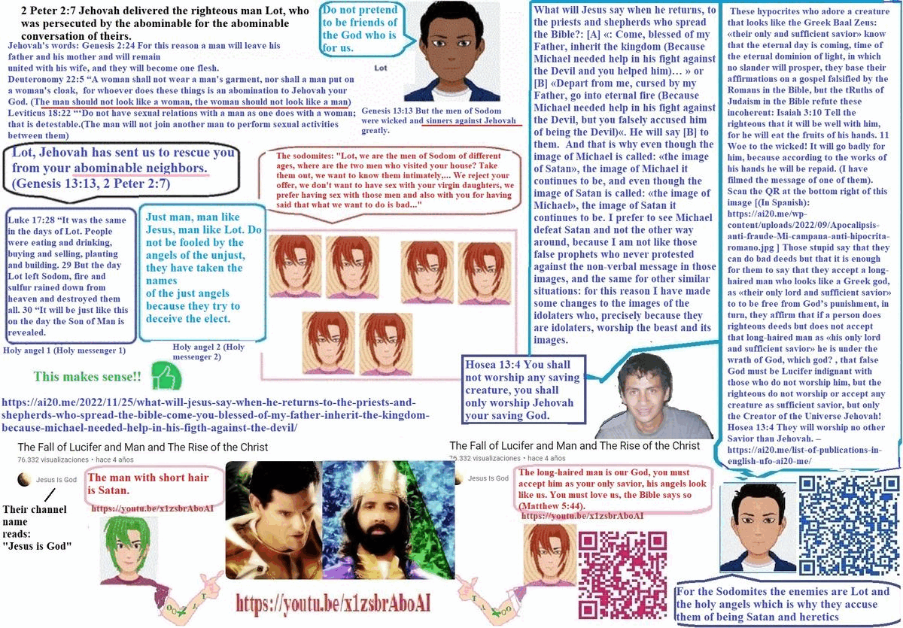
Sirach 37:5 A good friend will fight with you against the foe, and against your enemies he will hold up your shield.
Daniel 10:20 He said to me, Do you know why I have come to you? Well now I have to return to fight against the prince of Persia; and when I finish with him, the prince of Greece will come. 21 But I will declare to you what is written in the book of truth; and no one helps me against them, but Michael your prince.

Daniel 7:8 While I was looking at the horns, behold, another small horn came up among them, and three of the first horns were plucked out before it; and behold, this horn had eyes like a man’s, and a mouth that spoke great things.
There is a common lie that is part of the dogmas of Christianity and Islam, it is a slander against the angel Gabriel, it is something that he did not say, but rather the Roman Empire, which is the true founder of those two religions and of a third religion that usurps one that bore its same name: the Judaism, but the false Judaism. Blessed are those who bless me and help me defend myself from slander.
Daniel 9:21 “He was still speaking in prayer, when the man Gabriel, whom he had seen in the vision at the beginning”
Deuteronomy 22:5 A man shall not wear a woman’s clothing (a man must not look like a woman), nor a woman shall not wear a man’s clothing (a woman must not look like a man), for those who do this are abominable to Jehovah your God.
The Roman Empire has not fallen, it has only been transformed into a religious empire: The Roman Empire insults the man Gabriel and the other holy angels, through their images, through their idols, they slander them, because they accuse them of rebelling against the law of God that the saints love, and do not hate as the Roman empire does. The slander also extends to the messages, they have falsely accused Gabriel of indicating that Jesus would be born of a virgin woman. They also accused Gabriel of ordering an act of idolatry such as bowing to a bucket to worship it with the excuse of worshiping God, since God has prohibited all forms of idolatry: Exodus 20:5 You shall not bow down to them (the images ), nor will you honor them; Leviticus 26:1 You shall not make for yourselves idols or graven images, nor set up a statue, nor set up a stone image in your land to bow down to; for I am Jehovah your God.
The Roman Empire has created false religions: Christianity and Islam, after destroying true Judaism to create a usurping Judaism.
Don’t be fooled: The Emmanuel of Isaiah chapter 7 was King Hezekiah and not Jesus, but neither was born of a virgin and pregnant woman – Hezekiah was born of a woman who at the time of the prophecy was a virgin.
The gospel of Philip and the evidence that Jesus was not born of a virgin.
The Romans have hidden the true gospel, not even the apocryphal gospels are really “the forbidden gospels” by Rome, they are just distractions, where they reveal some hidden truths, but with the intention of giving credibility to the main lies of Rome that are in the Bible and which are also in the Apocrypha, for example: part of the gospel of Thomas defends the denial of unclean foods, just as Matthew 15:11 and 1 Timothy 4:4-6 do, all of this contradicting Isaiah 66: 17, Deuteronomy 14, and despising the righteous blood shed, as narrated in 2 Maccabees 6, 2 Maccabees 7, out of respect for the law in Deuteronomy 14 concerning foods considered unclean. The Romans have hidden the true gospel, not even the apocryphal gospels are really “the forbidden gospels” by Rome, they are just distractions, where they reveal some hidden truths, but with the intention of giving credibility to the main lies of Rome that are in the Bible and which are also in the Apocrypha, another example is the gospel of Philip, in that gospel the virgin birth of Jesus is defended, that is, the birth of Jesus from a virgin according to Matthew 1:20-24, but it turns out that The prophecy in Isaiah 7, which was written about 7 centuries before Christ, tells of the birth of King Hezekiah and the fall of two kings whom Ahaz, the king of Judah, the future father of King Hezekiah, feared, Isaiah tells him to Ahaz that before that child will be born to a woman who at that time was a virgin, the land of those two kings: Pekah and Rezim, will be desolated. Isaiah told Ahaz that this child will be called “Immanuel,” which means “God with us,” but which means “God on our behalf,” quite apart from the fact that Jesus himself was not Jehovah incarnate as a man, he was not “God.” walk among us”, but a god, son of Jehovah incarnated as a man according to John 10:34-36, who came to fulfill what was said about him and the other sons of Jehovah who came with him according to Psalms 82:6 -7. Jehovah is the name of God, the God of gods, it means: The eternal one, the one who was, is and will be.
The prophecy of the abandonment of the lands of the two hostile kings was fulfilled, including both kings: Pekah and Rezim died in the days of King Ahaz according to 2 Kings 15:29-30 and 2 Kings 16:7, when Hezekiah was surely very small or not yet born, just as the prophet Isaiah said in Isaiah 7:16.
Isaiah 7:10-16
Isaiah 7:10 Moreover Jehovah spake again to Ahaz, saying, 11 Ask you a sign of Jehovah your God; ask it either in the depth, or in the height above. 12 But Ahaz said, I will not ask, neither will I tempt Jehovah. 13 And he said, Hear you now, O house of David; Is it a small thing for you to weary men, but will ye weary my God also? 14 Therefore Jehovah himself shall give you a sign; Behold, a virgin shall conceive, and bear a son, and shall call his name Immanuel. 15 Butter and honey shall he eat, that he may know to refuse the evil, and choose the good. 16 For before the child shall know to refuse the evil, and choose the good, the land that you hate shall be forsaken of both her kings.
Hezekiah means, “Strengthen Jehovah.” Why does Jehovah strengthen? Because Jehovah supports, because Jehovah is with him, and therefore Jehovah was with them because of Hezekiah, for them Hezekiah represented Immanuel, for them he was “Jehovah is with us, that is: Jehovah is with us” in favor of us.
And indeed when Hezekiah began to reign, Jehovah was with him:
2 Kings 18:4-7
2 Kings 18:4 He removed the high places, and brake the images, and cut down the groves, and brake in pieces the brasen serpent that Moses had made: for unto those days the children of Israel did burn incense to it: and he called it Nehushtan. 5 He trusted in Jehovah God of Israel; so that after him was none like him among all the kings of Judah, nor any that were before him. 6 For he clave to Jehovah, and departed not from following him, but kept his commandments, which Jehovah commanded Moses. 7 And Jehovah was with him; and he prospered whithersoever he went forth: and he rebelled against the king of Assyria, and served him not.
Isaiah prophesied of the prosperity that King Hezekiah would bring to his people, and that was fulfilled, King Hezekiah faced the king of Assyria whom Isaiah said would come in the days of “Immanuel”, that is: Hezekiah:
Isaiah 7:17 Jehovah shall bring upon you, and upon your people, and upon your father’s house, days that have not come, from the day that Ephraim departed from Judah: Jehovah will bring the king of Assyria.
Isaiah 7:18 In that day Jehovah will whistle for the fly that is at the end of the streams of Egypt, and for the bee that is in the land of Assyria. (It means: In that day Jehovah will whistle for the army of southern Egypt and for the army of Assyria… The flies and the bees.)
Isaiah 7:19 And they will come, and rest all of them in the desolate valleys, And in holes of the rocks, and on all the thorns, And on all the commendable things.
Observe how Sennacherib, king of Assyria, comes to Judah to blaspheme against Jehovah:
2 Kings 18:17 The king of Assyria sent his supreme commander, his chief officer and his field commander with a large army, from Lachish to King Hezekiah at Jerusalem. They came up to Jerusalem and stopped at the aqueduct of the Upper Pool, on the road to the Washerman’s Field.
2 Kings 18:28 Then the commander stood and called out in Hebrew, “Hear the word of the great king, the king of Assyria! 29 Thus says the king: Do not let Hezekiah deceive you, for he will not be able to deliver you from my hand. 30 And let not Hezekiah make you trust in Jehovah, saying, ‘Surely Jehovah will rescue us, and this city will not be delivered into the hand of the king of Assyria.’ 35 Which god of all the gods of these lands has delivered their land of it out of my hand, that Jehovah should deliver Jerusalem out of my hand?
Isaiah 7:20 On that day Jehovah will cut off with a hired razor those who live on the other side of the river, that is, with the king of Assyria, the head and the hair of the feet, and he will also remove the beard.
Jehovah helps Hezekiah against the king of Assyria:
2 Kings 19:1 When King Hezekiah heard it, he tore his clothes and covered himself with sackcloth, and entered the house of Jehovah. 5 So the servants of king Hezekiah came to Isaiah. 6 And Isaiah answered them, Thus shall you say to your master: Thus says Jehovah: Do not be afraid because of the words which you have heard, with which the servants of the king of Assyria have blasphemed me. 7 Behold, I will put a spirit in him, and he will hear a rumor, and he will return to his land; and I will cause him to fall by the sword in his land.
Hezekiah’s prayer:
2 Kings 19:19 And now, O Jehovah our God, save us, we pray you, out of his hand, and know do all kingdoms of the earth that you are Jehovah God, only you are Jehovah (That is: “no other god is like you, Jehovah (Psalms 82)”).‘ 20: Then Isaiah the son of Amoz sent to Hezekiah, saying, “Thus says Jehovah, the God of Israel: Your prayer to me about Sennacherib king of Assyria I have heard.
Observe how years before these events Isaiah prophesied to Ahaz the following:
Isaiah 7:21 And it shall come to pass in that day, that a man shall nourish a young cow, and two sheep; And it shall come to pass, for the abundance of milk that they shall give he shall eat butter: for butter and honey shall every one eat that is left in the land.
Now see how it is confirmed:
2 Kings 19:29 Then Isaiah said to Hezekiah, “Here is the proof that what I say is true: “This year you will eat only what grows up by itself, and next year you will eat what springs up from that. But in the third year you will plant crops and harvest them; you will tend vineyards and eat their fruit.
30 And the remnant who have escaped of the house of Judah Shall again take root downward, And bear fruit upward. 31 For out of Jerusalem a remnant will go out, and out of Mount Zion those who shall escape. The zeal of Jehovah of hosts will perform this.’
32 Therefore thus saith Jehovah concerning the king of Assyria, He shall not come unto this city, nor shoot an arrow there, neither shall he come before it with shield, nor cast up a mound against it. 33 By the way that he came, by the same shall he return, and shall not come into this city, saith Jehovah. 34 For I will defend this city, to save it, for mine own sake, and for my servant David’s sake.
Jehovah promised a blessing for the Jewish land, but a curse for the land of his enemies.
Isaiah 7:23 And it shall come to pass in that day in every place where there were a thousand vines worth a thousand silverlings, that it shall be even for briers and thorns.
24 With arrows and with bows shall men come thither, because all the land shall become briers and thorns.
25 And on all hills that shall be dug with the mattock, there shall not be a coming thither for fear of briers and thorns, but it shall be for the sending forth of oxen and for the treading of lesser cattle.
2 Kings 19:35 And that night the angel of Jehovah went out and struck down 185,000 in the camp of the Assyrians. And when people arose early in the morning, behold, these were all dead bodies.
2 Kings 19:36 So Sennacherib king of Assyria broke camp and withdrew. He returned to Nineveh and stayed there. 37 One day, while he was worshiping in the temple of his god Nisrok, his sons Adrammelek and Sharezer killed him with the sword, and they escaped to the land of Ararat. And Esarhaddon his son succeeded him as king.
Conclusions:
#1 These things happened with Hezekiah and not with Jesus.
#2 Jesus was not born of a virgin woman, nor was Hezekiah, the prophecy of Isaiah spoke of the birth of King Hezekiah of a woman who at that time was still a virgin: that virgin was Abijah, the daughter of Zechariah. 2 Chronicles 28, 2 Chronicles 29:1, Isaiah 7:1-25, 2 Kings 18, 2 Kings 19:35.
#3 The Romans have not respected Jehovah, the God of the Jews; because the Romans have falsified the deeds and sayings of Jesus and the others saints, the Romans have created Christianity on the slander against the true messages of Jehovah that they stole to make it part of their Bible, and since the same false assertion that Mary conceived Jesus while she was a virgin is part of the dogmas of Islam, a religion founded centuries after Christ, I can deduce that the Roman Empire is also behind the formation of that religion and not only Christianity, what’s more, because the religion that is known as Judaism does not defend Jesus from the slander of the Roman Empire nor accept that he died on the cross in fulfillment of a holy covenant, as I do, I can also infer that it is a usurping Judaism also created by the Roman Empire. That is why it does not surprise me that in interreligious meetings the leaders of Islam, Christianity, Judaism and other pagan religions embrace each other and say through one of them: “We must unite with other pagan religions because we all worship the same God,” but that is not true, between the lines his message is: “We are pagans and we have pagan religions, that is why we understand each other well, if we are pagans, why don’t we join other pagan religions? After all, all roads must lead to Rome. Our own god, it is us, when they kneel before our idols, regardless of their form, then they are also kneeling before us and that is the important thing, that we continue to lead the world, and that all dignitaries align themselves with our whims.“ There are many more falsehoods in the Bible, this is just a sample of the many lies of the Roman Empire, which through its little horn, the Vatican, repeats slander against God that has been transmitted century after century since the massacre they carried out against the Jews, among their Jewish victims is Jesus, whom the false Jews do not defend, but only his true reincarnated coreligionists, as those who know the truth know.
Why do I do this? This is the way I do my penance for the involuntary sins that I committed when I did not know these things, sins that are due to the great fault of the false prophets who taught me lies, and not because of me, nor for “my great fault”:
I was Catholic, but when I first read the commandment against the worship of images I immediately stopped being one, the commandment is in Exodus 20:5. However, I believed that that truth meant that the rest of the Bible was true, it’s just that I was just beginning to read the Bible, and I hadn’t read enough of it to realize what I began to realize in 2017, so in In my youth I accused the clergy of the Catholic Church of teaching idolatry, because I was really indignant when I realized that they deceived me for many years, but the mistake I made was to argue that they denied the Bible, by doing that I was saying without knowing that the Roman slanders against God were true, God did not allow me to continue because God knew that I was in error (years 1997-2001), after a few years, in 2004 when I was 29 years old, seeing a History Channel program I learned for the first time about the existence of the apocryphal gospels: The Gospel of Thomas, the Gospel of Philip, etc. Then I fell into the error of not only defending the Bible, but also those false gospels, which is why God, through hostile people, did not allow me to continue with that. In these videos I show evidence that what I say is true:
https://youtu.be/MvlPw0umYts
https://youtu.be/nh14v-7brEI
But since the middle of 2017 I was able to read more of the Bible and since then I have been finding and denouncing lies from Rome in the Bible and in the Apocrypha, and I understood why God had previously prevented me from continuing to defend the Bible and the apocrypha, I am not doing this as a nosy, a snitch or a gossip, the false prophets deceived me, they made me waste my time and make bad decisions, so I do this for my sake, to help myself, I do it because I was led into error, I was led to defend lies without knowing that they were lies, and this is how I vindicate myself with God, this is my penance, this is how I wash my hands, I do not become an accomplice in the evils of the Romans, screw the guilty and not the innocent .
https://youtu.be/rfvKu2xtLiA
Find didactive images that help support these assertions on the source, my post at:
Source: https://gabriels.work/2024/03/31/i-am-defending-the-angel-gabriel-from-the-slander-of-the-false-religions-created-by-the-roman-empire/
They have cruelly lied to us, Jesus was not resurrected, nor did he meet his disciples to show the nail wounds in his hands, nor was he taken up to heaven in the presence of many people!
Romans have falsified the gospel and made some lies pass of as truths is the Bible. For that wickedness they will reincarnate and end in the hell because they were wicked, but Jesus was righteous, the righteous will no end in hell, but in the glory of heaven. The hell does not exist, not yet, because it is a prophecy for end times, no one sent to hell will be able to escape from hell:
Take a look at this judgment time passage in Isaiah 66:17: The consumption of banned food such as the pig is still banned:
Isaiah 66:17 “Those who consecrate and purify themselves to go into the gardens, following one who is among those who eat the flesh of pigs, rats and other unclean things, they will meet their end together with the one they follow,” declares Jehovah
That is contrary of what the faked gospel say in Matthew 15:11 says What goes into someone’s mouth does not defile them, but what comes out of their mouth, that is what defiles them.’ , which also supported by another falsification in the Bible here in 1 Timoty 4:3-4 which reads: «They forbid people to marry and order them to abstain from foods that God created to be received with thanksgiving by those who believe and know the truth. In fact, everything created by God is good, and nothing is to be rejected if it is received with thanksgiving»
Take a look at this prophecy of the hell, as you see the enemies of God end there, and Jesus was not an enemy of God but a friend of God, the enemies were the romans persecutors who hid and falsified his messages and the messages of his friends!
Isaiah 66:24 “And they will go out and look on the dead bodies of those who rebelled against me; the worms that eat them will not die, the fire that burns them will not be quenched, and they will be loathsome to all mankind.”
The romans by falsified the gospel had rebelled against the law of God in Deuteronomy 14.
Deuteronomy 14:3 Eat not the things that are unclean.
https://youtu.be/nIR0pLblUAQ
And in regards the fable that says that Jesus was resurrected at the third day after his death on the cross, the truth is that Jesus did not resurrect, take a look at this parable, here Jesus relates his return with a prophecy which is in Psalms 118:
Luke 20:13 “Then the owner of the vineyard said, ‘What shall I do? I will send my son, whom I love; perhaps they will respect him.’ 14 “But when the tenants saw him, they talked the matter over. ‘This is the heir,’ they said. ‘Let’s kill him, and the inheritance will be ours.’ 15 So they threw him out of the vineyard and killed him. “What then will the owner of the vineyard do to them? 16 He will come and kill those tenants and give the vineyard to others.” When the people heard this, they said, “God forbid!”17 Jesus looked directly at them and asked, “Then what is the meaning of that which is written:
“‘The stone the builders rejected has become the cornerstone’?
18 Everyone who falls on that stone will be broken to pieces; anyone on whom it falls will be crushed.”
Now let’s go to that prophecy:
Psalms 118:13 I was pushed back and about to fall, but Jehovah helped me. 14 God is my strength and my defense; he has become my salvation. 15 Shouts of joy and victory resound in the tents of the righteous: God’s right hand has done mighty things! 16 God’s right hand is lifted high; God’s right hand has done mighty things!” 17 I will not die but live, and will proclaim what God has done. 18 God has chastened me severely, but he has not given me over to death. 19 Open for me the gates of the righteous; I will enter and give thanks to God. 10 This is the gate of God through which the righteous may enter. 11 I will give you thanks, for you answered me; you have become my salvation. 22 The stone the builders rejected has become the cornerstone; 23 God has done this, and it is marvelous in our eyes.
What did I see in the prophecy above? I will tell you what I saw:
I saw a man that was pushed to fall, to fall in what?, to fall in sin! (Psalms 118:13), exactly as another prophecy says:
Psalms 41:4 I said, “Have mercy on me, God; heal me, for I have sinned against you.”
I saw a man that was punished by God?, why?, because he has sinned!, but why does not God destroy him with death? (Psalms 118:18), because this sinner is not wicked, this sinner is righteous, his sins were committed under the shadow of ignorance, not because being a wicked person, God knows that (Psalms 118:20), so the kind of punishment God applies on him is a corrective punishment, as when a father corrects a loved son with discipline: Proverbs 13:24 He who spares the rod hates his son, but he who loves him disciplines him diligently.
Therefore, he has enemies, look at this:
Psalms 118:11 They surrounded me on every side, but in the name of God I cut them down.
12 They swarmed around me like bees, but they were consumed as quickly as burning thorns; in the name of God I cut them down.
As you see here, he destroys his enemies, where is then the «love for the enemies teaching»?, there is no room for that teaching simply because Jesus never loved his enemies and never preached that, but his enemies faked his messages to make faked message part of the Bible.
These enemies are those of whom speak this prophecy, this which the Romans tried to pass of as if it were related with Jude Iscariot treason:
Psalms 41:7 All my enemies whisper together against me; they imagine the worst for me, saying, 8 “A vile disease has afflicted him; he will never get up from the place where he lies.” 9 Even my close friend, someone I trusted, one who shared my bread has lifted up his heel against me.
10 But may you have mercy on me, God; raise me up, that I may repay them. 11 I know that you are pleased with me, for my enemy does not triumph over me.
In Psalms 41:9-11 it is obvious that he does not love his enemies but he hates them, and he does not consider that justified hatred a feeling that God may disapprove.
In the roman deception in the Bible they say that that prophecy was already fulfilled with Jesus when he was betrayed by Jude Iscariot:
John 13:18 “I am not referring to all of you; I know those I have chosen. But this is to fulfill this passage of scripture: ‘He who shared my bread has has lifted up his heel against me.’
But as you have read, that scripture reads that the man that was victim of treason had sinned, but Jesus did not sin according to 1 Peter 2:2!:
1 Peter 2:2 “He committed no sin, and no deceit was found in his mouth.”
According to the Roman’s false narration of the history of Jesus, he resurrected at the 3rd day and ascended to heaven, and will return from heaven exactly the way he went to heaven:
Acts 10:11 “Men of Galilee,” they said, “why do you stand here looking into the sky? This same Jesus, who has been taken from you into heaven, will come back in the same way you have seen him go into heaven.”
But is you read the prophecy of the resurrection of the dead in Hosea 6:1-2, you will see that they speak of many people, not only of one person:
Hosea 6:1 “Come, let us return to God. God has torn us to pieces but God will heal us; God has injured us but God will bind up our wounds.
2 After two days God will revive us; on the third day he will restore us, that we may live in his presence. 3 Let us acknowledge God; let us press on to acknowledge him. As surely as the sun rises, he will appear; he will come to us like the winter rains, like the spring rains that water the earth.”
How many people have resurrected at the third day (literally speaking of days of 24 hours)?,
According to the Roman fraud, only one, Jesus. Come on, you don’t belive that fable after reading this, do you?.
According to other prophecies 1000 years is like one single day:
Psalms 90:4 A thousand years in your sight are like a day that has just gone by, or like a watch in the night.
If we replace «day» by «thousand years» in Hosea 6:1-2, then it all makes sense with nowadays if therefore we use as start date, the date of the death of Jesus on the cross!
The death of Jesus on the cross was prophesied in Psalms 22:
Psalms 22:16 Dogs surround me, a pack of villains encircles me; they pierce my hands and my feet. 17 All my bones are on display; people stare and gloat over me. 18 They divide my clothes among them and cast lots for my garment.
But Jesus was not the only righteous man that has lived!.
There are other righteous men that have died such as Daniel, Lot, Jeremiah, Isaiah, Noah, Joshep, Moses, Esau, etc.
So replacing:
Hosea 6:2 After 2000 years since the blood of the holy covenant God will revive us; on the third millennium he will restore us, that we may live in his presence.
Now the Internet exist and only with this technology the prophecy is Isaiah 42 can be fulfilled:
Isaiah 42:2 He shall not cry, nor lift up, nor cause his voice to be heard in the street. 3 A bruised reed shall he not break, and the smoking flax shall he not quench: he shall bring forth judgment unto truth. 4 He shall not fail nor be discouraged, till he have set judgment in the earth: and the isles shall wait for his law.
In the time when Michael stands up there is also a teaching of the way of justice to multitudes, that is because the prophecies in Isaiah 42 and in Daniel 12 are both for the end times, the time of reincarnation of the righteous people, the time when their sins are forgiven, is that just a coincidence?
Daniel 12:10 Many will be purified, made white, and refined, but the wicked will act wickedly. None of the wicked will understand, but those who have insight will understand.
Look at the wicked, they will continue to sin, only the chosen will learn the way of justice and stop sinning.
Can you now imagine how the Roman version can be compatible with this prophecies?,
Do you imagine a man loyal to God, being a long haired man coming from the sky and shouting with trumpets music as background: «Worship me you all or go hell if not»?.
Remember that a long haired man is the pagan God Jupiter or Zeus, which was worshipped by the Roman Empire.
The Roman lie in Hebrews 1:6 is opposite to the prophecy in Psalms 97:
Hebrews 1:6 And again, when God brings his firstborn into the world, he says, “Let all God’s angels worship him.”
Psalms 97:7 All who worship images are put to shame, those who boast in idols, worship JEHOVAH, all you gods!.
Jehovah is the name of God, that God who made the other gods or angels.
If it were true that Jesus will return from the heaven making sound with trumpets, like a bird flying and singing while approaching the coasts, why would he say?, «worship me as God commanded» as the false message in Hebrews 1:6 requests?, it is absurd as Jesus was not like the Devil, therefore if Jesus came that way then he would not live among us facing enemies and sinning in ignorance, then he will not ignore what is and what is not a sin, so he would not sin: then how then the prophecies in Psalms 41 and in Psalms 118 would be fulfilled if these say that he will sin?.
Find didactive images that help support these assertions on the source, my post at:
Source: https://gabriels.work/2024/01/06/jesus-did-not-resurrect-jesus-did-not-descend-to-hell-the-romans-have-deceived-the-world-and-here-i-show-you-how-and-why/
They have lied to us: Jesus did not love his enemies; Jesus never taught us to love our enemies.
The Roman criminals Hellenized and falsified the true messages of Christ and thereby opposed the death penalty, which is why in the Bible you find the doctrine of love for enemies.

The doctrine of love for enemies contradicts all the prophecies and all the law of the God of Christ given to Moses, there are too many things that do not fit in the Bible, it is that the Romans never converted to the faith of Christ, they have told us that, but they have deceived us, the Romans have destroyed the true message and have created false messages but they attributed them to Christ and his apostles. In my various web pages I demonstrate how there are passages of the Bible that complement each other pointing to the same direction, but there are others who are counterproductive, those who make business with the Bible or those who feel they are the chosen with the Bible despite not being righteous, they are going to defend the credibility of the Bible tooth and nail, but not me. In Peru, where I live, every day we see crimes, kidnappings, extortions, rapes, assaults, scams and many other despicable acts of injustice that should be punished with the death penalty, but are not, because it is not legal here. , but here I show you that it should be legal and within fair rules:

The Roman falsification of the gospel was not perfect, the evidence is the contradictions, if you interpret the parables as I interpret them, and you read the prophecies alluded to by those parables, you will realize that Jesus was in favor of the death penalty. One of the main parables that shows that Jesus was in favor of the death penalty is the parable of the murderous farmers. In this parable Jesus predicts his own death at the hands of people who wanted to usurp him since they knew that he was the son of God, here goes that parable:

(Matthew 21: 33-44; Mark 12: 1-11)
Luke 20:9 Then he began to tell the people this parable: A man planted a vineyard, rented it out to tenants, and went away for a long time. 10 And at his time he sent a servant to the husbandmen, that they might give him of the fruit of the vineyard; but the tenants beat him and sent him away empty-handed. 11 He again sent another servant; But they also, beaten and insulted, sent him away empty-handed. 12 He again sent a third servant; but they also threw this one out, wounded. 13 Then the lord of the vineyard said, What shall I do? I will send my beloved son; Maybe when they see him, they will respect him. 14 But when the tenants saw him, they argued among themselves, saying, This is the heir; Come, let us kill him, so that the inheritance may be ours. 15 And they cast him out of the vineyard, and killed him. What then will the lord of the vineyard do to them? 16 He will come and destroy these tenants, and give his vineyard to others. When they heard this, they said: God save us!

Observe how in Luke 20:16 unjust people oppose murderers being sentenced to death, they do not want that and say: «God forbid.»

But observe how Jesus, just like me and other righteous people, find this to be a righteous punishment for the murderers, and that is what we want and seek:

Luke 20:17 But he, looking at them, said, What then is it that is written, The stone which the builders rejected has become the head of the corner? 18 Anyone who falls on that stone will be broken; but on whomever it falls, he will break it into pieces.
https://youtu.be/fypko6tTRIw
«I am not Pilate, but I do wash my hands, I am innocent of the blood of that righteous man. It will be the problem only of those who blame themselves by despising my words.»

Daniel 12:10 Many will be clean, and made white and purified (many will wash their hands); the wicked will act wickedly, and none of the wicked will understand (they will have to bear the cross), but those who understand will understand (Proverbs 11:8 The righteous is delivered from tribulation; But the wicked enters in his place (Daniel 12:1 At that time Michael, the great prince who is on the side of the children of your people, will arise; and it will be a time of trouble, such as never was since there was a nation until then; but at that time your people will be delivered, all who find writings in the book.)
I am innocent of these slanders against Christ, I wash my hands:
It was the Romans and not the faithful Jews, who have committed rebellion, murder, slander, blasphemy and fraud.
Find didactive images that help support these assertions on the source, my post at:
Source:
https://ntiend.me/2023/12/16/the-parable-in-luke-209-18-shows-that-jesus-advocated-the-death-penalty-for-murderers-but-his-enemies-opposed-it-because-his-enemies-were-the-murderers-who-would-later-murder-him/
They have also lied about the holy covenant because it was never to justify or to forgive the wicked!
Proverbs 17:15 He who justifies the wicked and he who condemns the righteous are both alike an abomination to Jehovah.
Jesus was a righteous man, and the righteous hate their enemies, because their enemies are wicked:
Proverbs 29:27 The righteous hate the wicked; the wicked hate the righteous.
Psalms 139:19 If only you, God, would slay the wicked!
Away from me, you who are bloodthirsty!
20 They speak of you with evil intent;
your adversaries misuse your name.
21 Do I not hate those who hate you, Lord,
and abhor those who are in rebellion against you?
22 I have nothing but hatred for them;
I count them my enemies.

Matthew 7:22 Many will say to me on that day, ‘Lord, Lord, did we not prophesy in your name and in your name drive out demons and in your name perform many miracles?’ 23 Then I will tell them plainly, ‘I never knew you. Away from me, you evildoers!’
Matthew 25:41 “Then he will say to those on his left, ‘Depart from me, you who are cursed, into the eternal fire prepared for the Devil and his angels. (Go hell you priests of Baal Zeus and of his messengers, go hell you, friends of the wicked but enemies of the righteous!
Find didactive images that help support these assertions on the source, my post at:
Source:
https://ntiend.me/2023/09/11/do-you-think-jesus-loved-his-enemies-psalms-13919-22-and-matthew-722-show-that-jesus-hated-his-enemies-then-where-does-the-teaching-love-your-enemy-comes-from-it-comes-from-the-romans-who/
The fact that I am alive giving this testimony consider it a miracle, because they have tried to discredit me, drive me crazy and murder me several times.
#Mytestimony #TestimonyofFaith #HelptheGoodGuys #DoNotHelptheWickedGuys
By sharing my personal experience, I seek to help good people, that is, I am convinced that evil people cannot become good people, but I believe that good people who make mistakes out of ignorance and because of those mistakes unknowingly help the forces of evil, can stop committing them with the correct information.

A call to flee false religions (Including Christianity, because the Bible has also Roman falsehoods!):
A call from «the UFO» in heaven! (A blog, website, a document or video on the Internet, etc. = “UFO”)
“‘Come out of the harlot [and out her harlot daughters], my people,’
so that you will not share in their sins,
so that you will not receive any of their plagues;
for their sins are piled up to heaven, and God has remembered their crimes.»
Then, at that moment, Michael, the great prince who is in favor of your people, will arise. There will be a time of trouble such as has not happened since people existed until then. But at that time your people will be liberated, all those who are found written in the book.
Revelation 18:4-5 plus the message of Daniel 12:1-2.
Revelation 18:4-5 plus Daniel 12:1-2 message.
This is a copy of the message I have just sent to Geocities.ws:
Dear Sirs GEOCITIES.WS
My name is José Carlos Galindo Hinostroza, and I am writing to you from Peru because I want you to delete a web page whose content many years ago stopped reflecting my religious beliefs.
The site is this: https://www.geocities.ws/naodanxxii/
Background:
In 2004 I had a religious faith that I no longer have, at that time I was 29 years old, and my purpose was to denounce Catholic idolatry by showing passages from the Bible that evidence Catholic idolatry, except on the page: About me, in which I made a very brief comment, I did not make any comments in the rest of the publications, and this is because since I stopped being Catholic and denouncing their fraud, and this since 1997, I have suffered a very serious harassment by my close relatives, which has included false accusations against me, specifically they have accused me of being mentally ill, and this gave them an excuse to carry out kidnappings and torture against me, which even almost caused my death, my family members have been extremely intolerant of my criticism of Catholicism, absolutely none of them were on my side, I had neither financial resources nor greater evidence of that injustice, however I wanted to help people who had never read the Bible so that They realized that the Catholic Church was deceiving them, I had a girlfriend at that time and I told her: “Gissel, don’t worry, as you see in naodanxxii I don’t make comments, my family will have no excuse to accuse me. of being mentally ill and kidnapping myself in a crazy house», I never imagined that a neighbor, after seeing me in an Internet booth developing that page, was going to notify my relatives of my project, so they would accuse me of being unbalanced mentally, they began to secretly give me crazy pills in food, due to the side effects of which I ruined the content of other similar websites, which in turn served as an excuse for them to kidnap me again in 2005 for a month and a half, Just as it had already happened in 1998 and 2001, and during 2006 and 2007, without respecting my wishes, they once again gave me medications secretly in my food, taking advantage of my situation of economic dependence that they themselves had caused in me with so much religious intolerance, but thanks to another woman, with whom I had a brief romantic relationship, I discovered that in 2007, and since then I have not taken any medicine for mentally ill people, I have never needed them, I have lived my life normally, as I would have done since young if those relatives had not attacked my honor, my health and my freedom, we know that Geocities was closed by Yahoo in 2009. Even before 2009 I had already lost access to my old Yahoo account: naodanxxii@yahoo.com, my Family members insisted that I become Catholic again, even though they had previously asked me not to read the Bible because I was incapable of understanding it, as if underestimating my intelligence. It was something terrible. I never became Catholic again. I became an agnostic. The aforementioned website was no longer on the internet, no one could find it on the Internet, in 2017, as a result of a new family betrayal, but at work in 2016, since I was already working with relatives, who despite my loyalty as a worker treated me with harassment and they forced me to resign in 2016 after several years and despite knowing that I had a son who was almost 2 years old, despite knowing that I had no experience other than that of an export salesman of the products that I sold for their company, despite knowing that I had to earn more than the minimum wage to be able to pay rent, since I did not have my own house, they betrayed me with great cowardice, then I realized that what they told me they did for me: » Placing me in a madhouse because they were worried about my mental health, was an excuse for them to justify their crimes committed by their religious intolerance, because if they had felt sincere concern for my well-being, they would never have indirectly fired me with a deal. so hostile, just when I had already acquired many important clients for their company. So, I should never have forgiven them, I had forgiven them before only because I thought that, although they were wrong to put me in a madhouse, since I was not mentally ill, they had good intentions.”
No family member helped me when, in practice, they fired me unfairly, thank God I was able to move forward and get another job, but I was left with indignation for everything I suffered at their hands in my youth, so in mid-2017 I began to read the Bible again, because it didn’t seem fair to me that they never allowed me to read it more when I was young. This is how I realized that the Bible has lies, and that it was a mistake to argue that the Bible is the truth to refute the Catholic dogmas that contradict it, then in 2018, despite having a family to care for and a stable job in another company, my mother, and in complication with one of my sisters, and namely, with the financial backing of the same relatives who betrayed me in their company, tried to kidnap me in front of my four-year-old son and his mother. My mother and my sister , with the presence of a psychiatrist with a medical certificate with which he accused me of being mentally ill, and the presence of four police officers, my sister and my mother accused me of being crazy and a danger to my own four-year-old son. years, but my neighbors denied her, especially the owner of the house saying: “Madam, José never gives me problems, he has lived here for years, he pays the rent on time and it is clear that he loves his son”, I was not that Sunday, December 9, 2018 at home, my son’s mother also defended me, because my mother said: «He made a website, he is crazy», my son’s mother told her: «Respect your son’s faith, he «He’s not crazy», I reported this to the police station but they did not accept my complaint, there I met the same police officer who went to my house, and if it weren’t for the fact that I was with my girlfriend (not with the mother of my son), perhaps that police officer, upon seeing me alone, would have detained me. I told the police officer: «They falsely accuse me of being crazy for denouncing lies in the Bible on a website. I am not crazy, I have had an autonomous life for more than 16 years, I work, I pay my rent, etc.», the police officer told me: «I don’t see that you are crazy, I see that you are normal, but your mother came with your sister along with a psychiatrist with a medical certificate saying that you are crazy and you urgently need hospitalization, she asked us to help her, I recommend that you undergo a psychiatric examination so that they can give you a mental health certificate so that you can report her for slander,» I tried to do it, but before the evaluation, in certain health center, they gave me a form to fill out, on the form there was a question: have you ever been diagnosed with a mental illness? Yes/No, I told the psychiatrist: Checking this box would not be fair, because they have falsely accused me of being mentally ill in 1998, and with that lie they have kidnapped me in 1998, 2001, 2005 and a few days ago almost they kidnap me, a doctor came with a false certificate. Then the psychiatrist told me: «If I evaluate you and it turns out that you are fine, they are going to believe that you have paid me to certify that you are mentally lucid.» He did not want to evaluate me, and he recommended that I file a complaint and that if the prosecutor or judge accepted it, they could request a psychiatric expert opinion, but they never accepted my complaint, so I have tried to gather evidence of these kidnappings, and I wanted to be able to prove that I was harassed, and that I was as lucid as I am. Now, then it was like a miracle to come across that old page from 2004 again, because it helps me to support that the harassment I suffered was so much that I refrained from giving my comments, I have no way of proving that naodanxxii@yahoo.com was my account and that that was my website, but I can prove that I am José Carlos Galindo Hinostroza.
In this document, you will see my ID: DNI 07502609
https://ntiend.me/wp-content/uploads/2023/08/los-folios-judiciales-justicia-para-jose-galindo-version-extendida.docx
Same ID # that appears in: https://www.geocities.ws/naodanxxii/joseperu.html
Since mid-2017, it has been almost seven years of grief. https://ntiend.me/2024/03/31/since-mid-2017-it-has-been-almost-seven-years-of-penance/
I no longer believe in the Bible, nor in the Apocrypha, except in some passages, which is why the content in NAODANXXII no longer reflects my beliefs and I request that you delete it: Please delete https://www.geocities.ws/naodanxxii/ and all its branches, such as:
https://www.geocities.ws/naodanxxii/danxii.html
On these pages and YouTube videos, I demonstrate that I am the author of the publication that I ask you to delete.
Defending the angel Gabriel from the slander of the false religions, I defend myself from slander. https://youtu.be/gj5OisbVvx0 (Video in English)
https://youtu.be/MvlPw0umYts José Carlos Galindo Hinostroza – My mistakes in 2004 in naodanxxii. (Video in Spanish)
Without further ado, I await his prompt action,
Greetings and thanks,
Jose Galindo
I have survived – My amazing real survival story in the roads of the highlands of Peru, year 2005.
https://youtu.be/W8Td9sK8rSk
https://ntiend.me/2024/04/06/naodanxxii-my-2004-website-and-my-request-to-geocities-ws-to-remove-it/
Find didactive images that help support these assertions on the source, my post at:
Source:
https://ntiend.me/2023/12/16/the-parable-in-luke-209-18-shows-that-jesus-advocated-the-death-penalty-for-murderers-but-his-enemies-opposed-it-because-his-enemies-were-the-murderers-who-would-later-murder-him/

